Presentation 2: Sacraments of Initiation
Slide | Notes
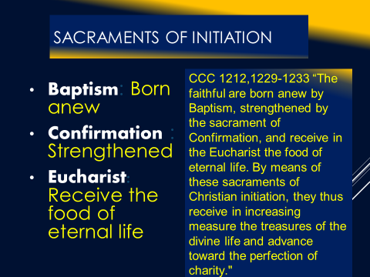 | Christian Initiation  Story: Baptism of Euphemius  1229 From the time of the apostles, becoming a Christian has been accomplished by a journey and initiation in several stages. This journey can be covered rapidly or slowly, but certain essential elements will always have to be present: proclamation of the Word, acceptance of the Gospel entailing conversion, profession of faith, Baptism itself, the outpouring of the Holy Spirit, and admission to Eucharistic communion.  1230 This initiation has varied greatly through the centuries according to circumstances. In the first centuries of the Church, Christian initiation saw considerable development. A long period of catechumenate included a series of preparatory rites, which were liturgical landmarks along the path of catechumenal preparation and culminated in the celebration of the sacraments of Christian initiation.  1232 The second Vatican Council restored for the Latin Church "the catechumenate for adults, comprising several distinct steps."³⁴ The rites for these stages are to be found in the Rite of Christian Initiation of Adults (RCIA).³⁵ The Council also gives permission that: "In mission countries, in addition to what is furnished by the Christian tradition, those elements of initiation rites may be admitted which are already in use among some peoples insofar as they can be adapted to the Christian ritual.”  1285 Baptism, the Eucharist, and the sacrament of Confirmation together constitute the "sacraments of Christian initiation," whose unity must be safeguarded.
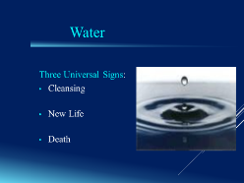
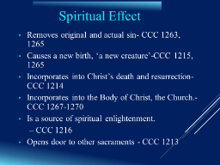 | On Sin: CCC 1264 Yet certain temporal consequences of sin remain in the baptized, such as suffering, illness, death, and such frailties inherent in life as weaknesses of character, and so on, as well as an inclination to sin that Tradition calls concupiscence, or metaphorically, "the tinder for sin" (fomes peccati); since concupiscence "is left for us to wrestle with, it cannot harm those who do not consent but manfully resist it by the grace of Jesus Christ."⁶⁷ Indeed, "an athlete is not crowned unless he competes according to the rules."
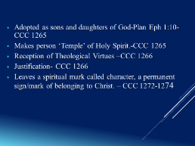 | On Justification: CCC 1992Justification has been merited for us by the Passion of Christ who offered himself on the cross as a living victim, holy and pleasing to God, and whose blood has become the instrument of atonement for the sins of all men. Justification is conferred in Baptism, the sacrament of faith. It conforms us to the righteousness of God, who makes us inwardly just by the power of his mercy. Its purpose is the glory of God and of Christ, and the gift of eternal life:
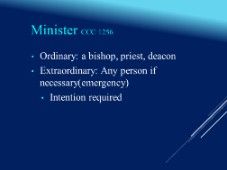 | 1256-The ordinary ministers of Baptism are the bishop and priest and, in the Latin Church, also the deacon.⁵⁷In case of necessity, anyone, even a non-baptized person, with the required intention, can baptize, by using the Trinitarian baptismal formula. The intention required is to will to do what the Church does when she baptizes. The Church finds the reason for this possibility in the universal saving will of God and the necessity of Baptism for salvation
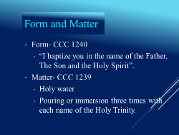 | CCC 1228 St. Augustine says of Baptism: "The word is brought to the material element, and it becomes a sacrament."³³
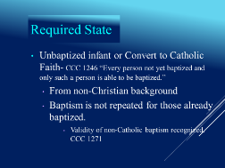 | Non-Catholic Christians CCC 1271 Baptism constitutes the foundation of communion among all Christians, including those who are not yet in full communion with the Catholic Church: "For men who believe in Christ and have been properly baptized are put in some, though imperfect, communion with the Catholic Church. Justified by faith in Baptism, [they] are incorporated into Christ; they therefore have a right to be called Christians, and with good reason are accepted as brothers by the children of the Catholic Church."⁸¹ "Baptism therefore constitutes the sacramental bond of unity existing among all who through it are reborn."  CCC 1272 Given once for all, Baptism cannot be repeated.
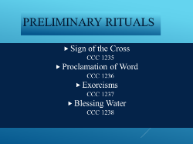 | CCC 1237 exorcism: Since Baptism signifies liberation from sin and from its instigator the devil, one or more exorcisms are pronounced over the candidate. The celebrant then anoints him with the oil of catechumens, or lays his hands on him, and he explicitly renounces Satan. Thus prepared, he is able to confess the faith of the Church, to which he will be "entrusted" by Baptism.  “Almighty and ever-living God, you sent your only Son in to the world to cast out the power of Satan, spirit of evil, to rescue man from the kingdom of darkness, and bring him into the kingdom of light. We pray for this child: set him free from original sin, make him a temple of your glory, and send your Holy Spirit to dwell with him. We ask this through Christ our Lord.”  Compare that to the prayers of exorcism from the old Rites which I here reproduce in English, though in EF Baptisms I say them in Latin:  Go forth from him (her), unclean spirit, and give place to the Holy Spirit, the Paraclete.  I exorcise thee, unclean spirit, in the name of the Father + and of the Son, + and of the Holy + Spirit, that thou goest out and depart from this servant of God, N. For He commands Thee, accursed one, Who walked upon the sea, and stretched out His right hand to Peter about to sink. Therefore, accursed devil, acknowledge thy sentence, and give honor to the living and true God: give honor to Jesus Christ His Son, and to the Holy Spirit; and depart from this servant of God, N. because God and our Lord Jesus Christ hath vouchsafed to call him (her) to His holy grace and benediction and to the font of Baptism.  And this sign of the holy Cross, which we make upon his (her) forehead, do thou, accursed devil, never dare to violate. Through the same Christ our Lord  I exorcise thee, every unclean spirit, in the name of God the Father + Almighty, in the name of Jesus + Christ, His Son, our Lord and Judge, and in the power of the Holy + Spirit, that thou be depart from this creature of God N, which our Lord hath deigned to call unto His holy temple, that it may be made the temple of the living God, and that the Holy Spirit may dwell therein. Through the same Christ our Lord, who shall come to judge the living and the dead, and the world by fire!
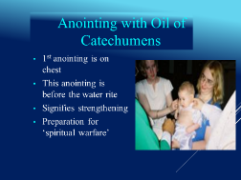 | “We anoint with this oil those who are approaching the divine rebirth, praying to the Lord Jesus Christ to impart to it a power to heal and strengthen, and by its means, to heal in the body, the soul and spirit of those who are to be baptized freeing it of every trace of sin and iniquity, so that they may have strength to triumph over the attacks of hostile powers.’ Serapion 4th Century Egyptian Bishop  “…(he) begins by anointing the body of the postulant with holy oils, thus in symbol calling the initiate to the holy contests which he will now have to undertake under the direction of Christ, for it is He , who God as he is, orders the combat…” Pseudo-Dionysius 5th Century, Theologian-philosopher
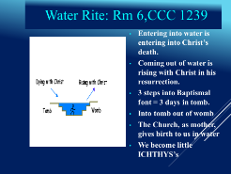 | 1227 According to the Apostle Paul, the believer enters through Baptism into communion with Christ's death, is buried with him, and rises with him: ‘Do you not know that all of us who have been baptized into Christ Jesus were baptized into his death? We were buried therefore with him by baptism into death, so that as Christ was raised from the dead by the glory of the Father, we too might walk in newness of life.’ Rm 6:3-4  “Cyril of Jerusalem shows us that the descent into the baptismal pool is as it were a descent into the waters of death which are the dwelling place of the dragon of the sea, as Christ went down into the Jordan to crush the power of the dragon who was hidden there…Jesus chained fast the strong one, so that we might gain the power to tread on scorpions and serpents…Having gone down into the waters dead in sin, you come out brought to life in justice”. The Bible and The Liturgy, Jean Danielou
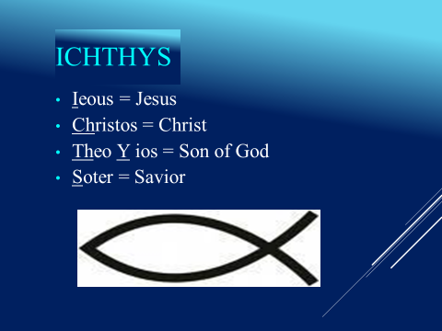 | St. Ambrose, “But why are you plunged into the water?...We read ‘May the waters bring forth living creatures’(Gen 1:20). And the living creatures were born’ This happens at the beginning of creation. But for you it was reserved that water should bring forth to grace(divine life), as that other water brought forth creatures to natural life imitate this fish…”  Tertullian, “We are little fishes according to the ICHTHYS, Jesus Christ in Whom we are born. And we only live by remaining in the water.”
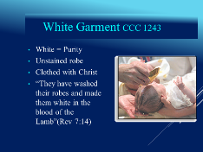
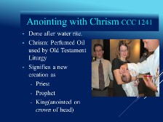 | CCC1268 The baptized have become "living stones" to be "built into a spiritual house, to be a holy priesthood."⁷⁴ By Baptism they share in the priesthood of Christ, in his prophetic and royal mission. They are "a chosen race, a royal priesthood, a holy nation, God's own people, that [they] may declare the wonderful deeds of him who called [them] out of darkness into his marvelous light."⁷⁵ Baptism gives a share in the common priesthood of all believers.
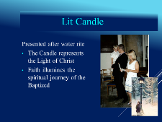 | 1216 "This bath is called enlightenment, because those who receive this [catechetical] instruction are enlightened in their understanding . . . ."⁸ Having received in Baptism the Word, "the true light that enlightens every man," the person baptized has been "enlightened," he becomes a "son of light," indeed, he becomes "light" himself
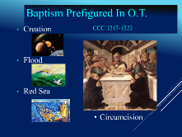 | 1217 In the liturgy of the Easter Vigil, during the blessing of the baptismal water, the Church solemnly commemorates the great events in salvation history that already prefigured the mystery of Baptism:  Father, you give us grace through sacramental signs,  which tell us of the wonders of your unseen power.  In Baptism we use your gift of water,  which you have made a rich symbol  of the grace you give us in this sacrament.¹¹  1218 Since the beginning of the world, water, so humble and wonderful a creature, has been the source of life and fruitfulness. Sacred Scripture sees it as "overshadowed" by the Spirit of God:¹²  At the very dawn of creation  your Spirit breathed on the waters,  making them the wellspring of all holiness.¹³  1219 The Church has seen in Noah's ark a prefiguring of salvation by Baptism, for by it "a few, that is, eight persons, were saved through water":¹⁴  The waters of the great flood  you made a sign of the waters of Baptism,  that make an end of sin and a new beginning of goodness.¹⁵  1220 If water springing up from the earth symbolizes life, the water of the sea is a symbol of death and so can represent the mystery of the cross. By this symbolism Baptism signifies communion with Christ's death.  1221 But above all, the crossing of the Red Sea, literally the liberation of Israel from the slavery of Egypt, announces the liberation wrought by Baptism:  You freed the children of Abraham from the slavery of Pharaoh,  bringing them dry-shod through the waters of the Red Sea,  to be an image of the people set free in Baptism.¹⁶  1222 Finally, Baptism is prefigured in the crossing of the Jordan River by which the People of God received the gift of the land promised to Abraham's descendants, an image of eternal life. The promise of this blessed inheritance is fulfilled in the New Covenant.
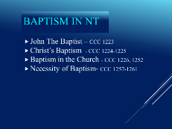 | 223 All the Old Covenant prefigurations find their fulfillment in Christ Jesus. He begins his public life after having himself baptized by St. John the Baptist in the Jordan.¹⁷ After his resurrection Christ gives this mission to his apostles: "Go therefore and make disciples of all nations, baptizing them in the name of the Father and of the Son and of the Holy Spirit, teaching them to observe all that I have commanded you."¹⁸  1224 Our Lord voluntarily submitted himself to the baptism of St. John, intended for sinners, in order to "fulfill all righteousness."¹⁹ Jesus' gesture is a manifestation of his self-emptying.²⁰ The Spirit who had hovered over the waters of the first creation descended then on the Christ as a prelude of the new creation, and the Father revealed Jesus as his "beloved Son."²¹  Opening the Eyes of Faith  Gospel Commentary for 4th Sunday of Lent  FEBRUARY 29, 2008ZENIT STAFFSPIRITUALITY AND PRAYER  By Father Raniero Cantalamessa, OFM Cap  ROME, FEB. 29, 2008 (Zenit.org).- The healing of the man blind from birth hits close to home, because in a certain sense all of us are blind from birth.  The very world was born blind. According to what science tells us today, during millions of years there was life on earth, but it was life in a blind state. The eye for seeing did not exist yet, sight itself did not exist. The eye, in its complexity and perfection, is one of the functions formed more slowly.  This situation is reproduced in part in the life of every man. A child is born, though not precisely blind, at least incapable of distinguishing things clearly. Only after weeks he begins to focus. If the child could express what he experiences when he begins to see clearly the face of his mother, of people, of things, of colors — how many “oh’s” of awe would be heard! What a hymn to light and sight.  To see is a miracle, only we don’t pay attention to it because we are too accustomed to it and we take it for granted. It is here that God sometimes acts in a sudden and extraordinary way, aiming to take us out of drowsiness and make us alert. That is what he did with the healing of the man blind from birth and of other blind people in the Gospel.  But is this the only reason that Jesus healed the man blind from birth? There is another sense in which we were born blind. There are other eyes — besides the physical ones — that should open themselves to the world: the eyes of faith! They allow a glimpse of another world beyond that which we see with the eyes of the body: the world of God, of eternal life, the world of the Gospel, the world that does not end — not even with the end of the world.  This is what Jesus wanted to remind us of with the healing of the man blind from birth. Before anything else, he sent the young blind man to the pool of Siloam. With this, Jesus wanted to signify that these different eyes, those of faith, begin to open up in baptism, precisely when we receive the gift of faith. That’s why in ancient times baptism was also called “illumination,” and being baptized meant “having been illuminated.”  In our case, it’s not about believing generically in God, but believing in Christ. The Evangelist avails of the episode to show us how to arrive to a full and mature faith in the Son of God. The blind man’s recovery of his sight happens, in fact, at the same time that he discovers who Jesus is. In the beginning, for the blind man, Jesus is no more than a man. “The man called Jesus made clay …”  Later, he was asked, “What do you have to say about him, since he opened your eyes?” He responded, “He is a prophet.” He has taken a step forward; he has understood that Jesus is sent form God, which he speaks and acts in his name.  Finally, finding Jesus again, he exclaims, “I do believe Lord,” and he bows before him to worship him, thus openly recognizing him as his Lord and God.  In describing all of this with so much detail, it is as if John the Evangelist very discreetly invites us to ask ourselves the question: “And me? In what point am I on this path? Who is Jesus of Nazareth for me?”  That Jesus is a man, no one denies. That he is a prophet, one sent from God, is also admitted almost universally. Many stay at that point. But it is not enough. A Muslim, if he is coherent with what is found written in the Koran, also recognizes that Jesus is a prophet. But not for that is one considered a Christian.  The leap by which one passes to be a Christian in the true sense is when he proclaims, like the man blind from birth, that Jesus is “Lord” and adores him as God. Christian faith is not primarily to believe in something — that God exists, that there is something beyond — but to believe in someone. Jesus in the Gospel does not give us a list of things to believe; he says, “Believe in God; believe also in me” (John 14:1).  For Christians, to believe is to believe in Jesus Christ.
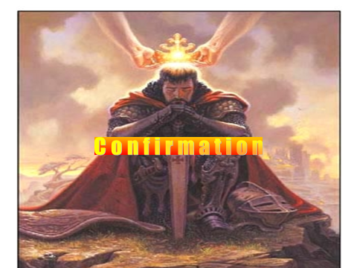  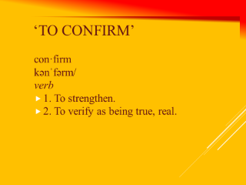 | Relation to Baptism:  CCC 1285- It must be explained to the faithful that the reception of the sacrament of Confirmation is necessary for the completion of baptismal grace.  CCC 1298 When Confirmation is celebrated separately from Baptism, as is the case in the Roman Rite, the Liturgy of Confirmation begins with the renewal of baptismal promises and the profession of faith by the confirmands. This clearly shows that Confirmation follows Baptism.¹¹¹When adults are baptized, they immediately receive Confirmation and participate in the Eucharist.  CCC 1306- Baptism is certainly valid and efficacious, but Christian initiation remains incomplete.  Tertullian : “The flesh, indeed, is washed, in order that the soul may be cleansed; the flesh is anointed, that the soul may be consecrated; the flesh is signed (with the cross), that the soul too may be fortified; the flesh is shadowed with the imposition of hands, that the soul also may be illuminated by the Spirit; the flesh feeds on the body and blood of Christ, that the soul likewise may fatten on its God.”  Strengthen: For "by the sacrament of Confirmation, [the baptized] are more perfectly bound to the Church and are enriched with a special strength of the Holy Spirit.  Verify: Because of Baptism…“This is my beloved son in whom I am well pleased.”
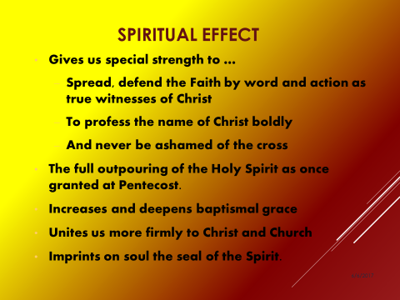 | CCC 1285- Hence they are, as true witnesses of Christ, more strictly obliged to spread and defend the faith by word and deed.  In 350 AD St. Cyril of Jerusalem, “Just as Christ, after his baptism and the coming upon him of the Holy Spirit went forth and defeated the adversary, so also with you. After holy Baptism and the Mystical Chrism, having put on the full suit of armor of the Holy Spirit, you are to withstand the power of the adversary, and defeat him, saying, ‘I am able to do all things through Christ who strengthens me”.  Ephesians 6: 13-17 Armor of God  That I may be able to stand firm against the devices of the devil,  I now put on the whole Armor of God.  I put on the helmet of Salvation.  I put on the breastplate of Righteousness, and the belt of Truth.  I put on the shoes for spreading the Gospel of Peace.  I carry the shield of Faith and the sword of the Spirit, the Word of God.
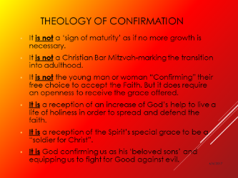 | CCC 1308 Although Confirmation is sometimes called the "sacrament of Christian maturity," we must not confuse adult faith with the adult age of natural growth, nor forget that the baptismal grace is a grace of free, unmerited election and does not need (our) "ratification" to become effective.
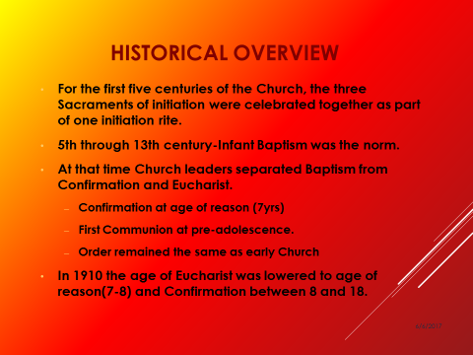 | Reason for separation…  - Confirmation and Baptism used to be one double-Sacrament.  - Eventually at the rise in numbers of Baptisms the Bishop confirmed the baptized at a later date.
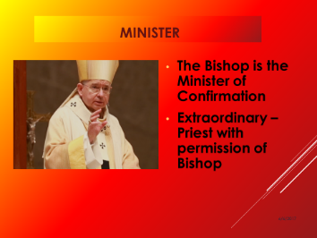 | CCC 1312- The original minister of Confirmation is the bishop.¹³⁰  In the East, ordinarily the priest who baptizes also immediately confers Confirmation in one and the same celebration. But he does so with sacred chrism consecrated by the patriarch or the bishop, thus expressing the apostolic unity of the Church whose bonds are strengthened by the sacrament of Confirmation.  CCC 1314- If a Christian is in danger of death, any priest can give him Confirmation.
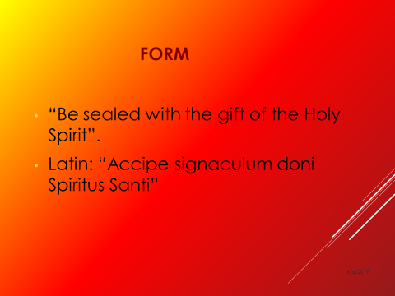 | 1295-By this anointing the confirmand receives the "mark," the seal of the Holy Spirit. A seal is a symbol of a person, a sign of personal authority, or ownership of an object.¹⁰⁶ Hence soldiers were marked with their leader's seal and slaves with their master's. A seal authenticates a juridical act or document and occasionally makes it secret.¹⁰⁷  1296 Christ himself declared that he was marked with his Father's seal.¹⁰⁸ Christians are also marked with a seal: "It is God who establishes us with you in Christ and has commissioned us; he has put his seal on us and given us his Spirit in our hearts as a guarantee."¹⁰⁹ This seal of the Holy Spirit marks our total belonging to Christ, our enrollment in his service for ever, as well as the promise of divine protection in the great eschatological trial.^{110…}  St. Cyril of Jerusalem, “ Forget not the Holy Spirit”, he says to the catechumens, “at the moment of your enlightenment: He is ready to mark your soul with His seal. He will give you the heavenly and divine seal which makes the devil tremble: He will arm you for the fight; He will give you strength”
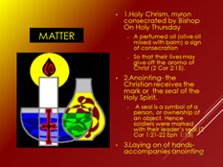 | - Oil-A perfumed oil (olive oil mixed with balm) a sign of consecration. So that their lives may give off the aroma of Christ (2 Cor 2:15).  - Anointing- A seal is a symbol of a person, or ownership of an object. Hence soldiers were marked with their leader’s seal.(2 Cor 1:21-22 Eph 1:13.  - Laying on Hands: The imposition of hands…perpetuates the grace of Pentecost in the Church.(CCC 1288)
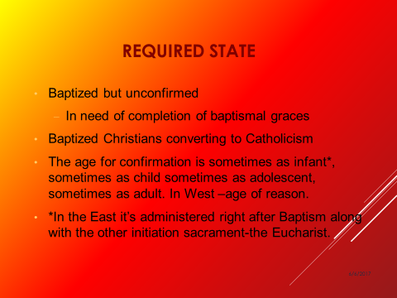

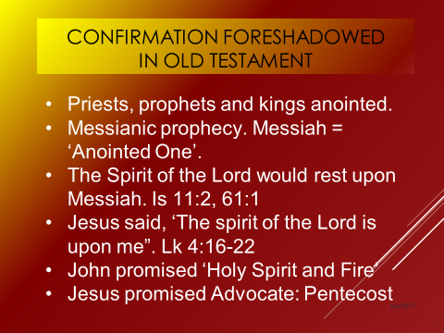

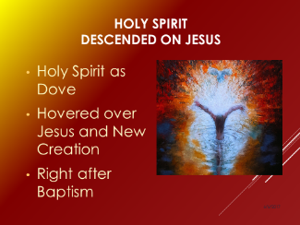

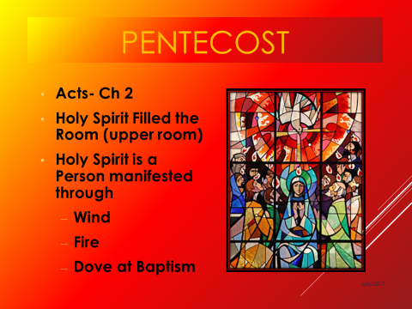 | Prayer asking for the outpouring of the Holy Spirit: “All powerful God, Father of our Lord Jesus Christ, by water and the Holy Spirit you freed your sons and daughters from sin and gave them new life.  Send your Holy Spirit upon them  To be their helper and guide.  Give them the spirit of wisdom and understanding, the spirit of right judgment and courage,  The spirit of knowledge and reverence.  Fill them with the spirit of wonder and awe in your presence.  We ask this through Christ our Lord”
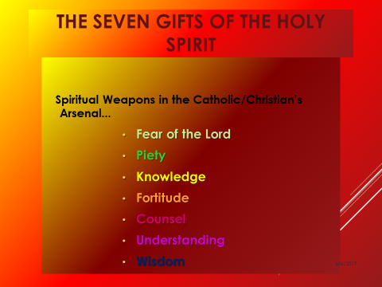 | 7 Gifts: Rooted in the prophecy of Isaiah about the coming of the Messiah  - “But a shoot shall sprout from the stump of Jesse, and from his roots a bud shall blossom. The Spirit of the Lord shall rest upon him: a spirit of wisdom and of understanding, a spirit of counsel and strength, a spirit of knowledge and fear of the Lord, and his delight shall be the fear of the Lord” (Is 11:1-3).  Fear-Awe and Wonder  - Not a fear of punishment but a reverential fear. Fear of the majesty of God out of awe.  - He’s the Creator (all Holy) we are merely his creation. Recognizing and respecting His power.  - Helps us to be aware of the sacred.  - “The beginning of wisdom is fear of the Lord”(Sirach 1:12)‏  - Leads to an increase in a temperance and chastity  - Fear of the Lord helps us to respect God and to desire to please him in everything. It is not a fear of God, but a fear of offending him  Piety  - Enables us to give loving worship to God as our Father.  - Enables us to live a life of holiness and prayer.  - Enables us to fulfill our obligations to God and neighbor.  - Enables us to fulfill the commands of God.  Knowledge  - Enables the intellect to know the truth.  - A special illumination to see that everything depends on God.  - The gift also gives the person certitude and faith.  - Enables us to know better whether something is a part of the Faith or in some way goes against it.  - Enables us to overcome difficulties and to endure pain and suffering with strength and power from God.  Fortitude  - Gives strength to- resist evil and persevere to everlasting life.  - To overcome all luke-warmness in service of God: to be fearless in one’s witness of the Faith to others.  - To endure persecution for being Christian.  Counsel  - Enables the person to judge individual acts as good and ought to be done or evil and ought to be avoided.  - Enables a person to have keen moral judgment of right and wrong.  - Helps us to have a clear conscience.  - Provide solutions to unexpected situations.  - Give good Christ-like advice to others.  Understanding  - Enables the person to grasp the truths of the Faith easily.  - Enables us to see how the teachings of the Church fit together as an organic whole.  - Helps us to penetrate into the meaning of Scriptures-signs, symbols,types,prophecy etc.  - Ability to “see” the unseen spiritual effects of Sacraments etc.  Wisdom  - Help in contemplation of the divine which flows from a loving communion, intimate union with God.  - Ability to see the bigger picture of how the Lord works in one’s life. To see His plan unfolding.
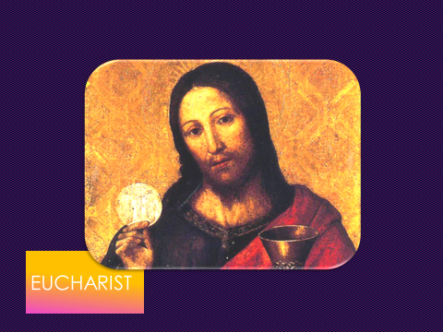 | Relationship to other Sacraments:  CCC 1322-The holy Eucharist completes Christian initiation. Those who have been raised to the dignity of the royal priesthood by Baptism and configured more deeply to Christ by Confirmation participate with the whole community in the Lord's own sacrifice by means of the Eucharist.  CCC 1324 The Eucharist is "the source and summit of the Christian life."¹³⁶ "The other sacraments, and indeed all ecclesiastical ministries and works of the apostolate, are bound up with the Eucharist and are oriented toward it. For in the blessed Eucharist is contained the whole spiritual good of the Church, namely Christ himself, our Pasch."
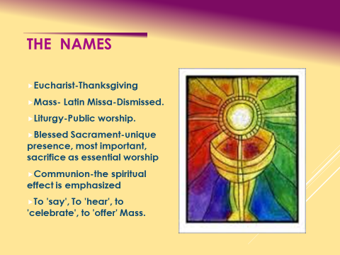 | WHAT IS THIS SACRAMENT CALLED?  1328 The inexhaustible richness of this sacrament is expressed in the different names we give it. Each name evokes certain aspects of it. It is called:  Eucharist, because it is an action of thanksgiving to God. The Greek words eucharistein¹⁴¹ and eulogein¹⁴²recall the Jewish blessings that proclaim - especially during a meal - God's works: creation, redemption, and sanctification.  1329 The Lord's Supper, because of its connection with the supper which the Lord took with his disciples on the eve of his Passion and because it anticipates the wedding feast of the Lamb in the heavenly Jerusalem.¹⁴³  The Breaking of Bread, because Jesus used this rite, part of a Jewish meat when as master of the table he blessed and distributed the bread,¹⁴⁴ above all at the Last Supper.¹⁴⁵ It is by this action that his disciples will recognize him after his Resurrection,¹⁴⁶ and it is this expression that the first Christians will use to designate their Eucharistic assemblies;¹⁴⁷ by doing so they signified that all who eat the one broken bread, Christ, enter into communion with him and form but one body in him.¹⁴⁸  The Eucharistic assembly (synaxis), because the Eucharist is celebrated amid the assembly of the faithful, the visible expression of the Church.¹⁴⁹  1330 The memorial of the Lord's Passion and Resurrection.  The Holy Sacrifice, because it makes present the one sacrifice of Christ the Savior and includes the Church's offering. The terms holy sacrifice of the Mass, "sacrifice of praise," spiritual sacrifice, pure and holy sacrifice are also used,¹⁵⁰ since it completes and surpasses all the sacrifices of the Old Covenant.  The Holy and Divine Liturgy, because the Church's whole liturgy finds its center and most intense expression in the celebration of this sacrament; in the same sense we also call its celebration the Sacred Mysteries. We speak of the Most Blessed Sacrament because it is the Sacrament of sacraments. The Eucharistic species reserved in the tabernacle are designated by this same name.  1331 Holy Communion, because by this sacrament we unite ourselves to Christ, who makes us sharers in his Body and Blood to form a single body.¹⁵¹ We also call it: the holy things (ta hagia; sancta)¹⁵² - the first meaning of the phrase "communion of saints" in the Apostles' Creed - the bread of angels, bread from heaven, medicine of immortality,¹⁵³ viaticum. . . .  1332 Holy Mass (Missa), because the liturgy in which the mystery of salvation is accomplished concludes with the sending forth (missio) of the faithful, so that they may fulfill God's will in their daily lives.
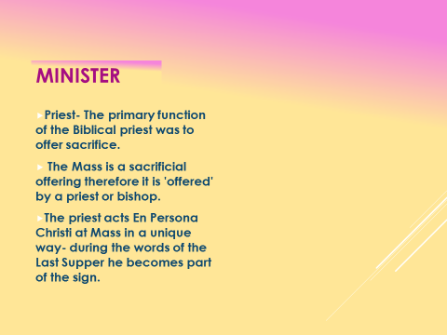 | CCC 1337- The Lord, having loved those who were his own, loved them to the end. Knowing that the hour had come to leave this world and return to the Father, in the course of a meal he washed their feet and gave them the commandment of love.¹⁶³ In order to leave them a pledge of this love, in order never to depart from his own and to make them sharers in his Passover, he instituted the Eucharist as the memorial of his death and Resurrection, and commanded his apostles to celebrate it until his return; "thereby he constituted them priests of the New Testament.
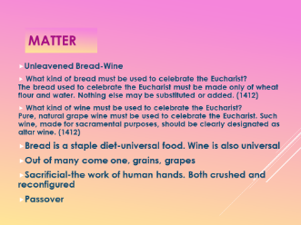 | CCC 1333- At the heart of the Eucharistic celebration are the bread and wine that, by the words of Christ and the invocation of the Holy Spirit, become Christ's Body and Blood. Faithful to the Lord's command the Church continues to do, in his memory and until his glorious return, what he did on the eve of his Passion: "He took bread. . . ." "He took the cup filled with wine. . . ." The signs of bread and wine become, in a way surpassing understanding, the Body and Blood of Christ; they continue also to signify the goodness of creation.  Thus in the Offertory we give thanks to the Creator for bread and wine,¹⁵⁴ fruit of the "work of human hands," but above all as "fruit of the earth" and "of the vine" - gifts of the Creator.  The Church sees in the gesture of the king-priest Melchizedek, who "brought out bread and wine," a prefiguring of her own offering.  Other OT Connections…CCC 1334  First fruits offering  Manna  Tabernacle bread of presence  Unleavened bread Passover  ‘Cup of Blessing’-Passover  NT Connections…CCC 1335  Manger  Multiplication of loaves  Wedding at Cana-Wine  Jn 6 Bread of Life Discourse (CCC 1336)
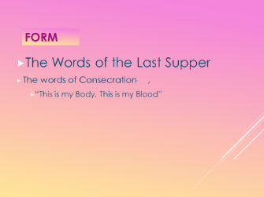 | CCC 1376 The Council of Trent summarizes the Catholic faith by declaring: "Because Christ our Redeemer said that it was truly his body that he was offering under the species of bread, it has always been the conviction of the Church of God, and this holy Council now declares again, that by the consecration of the bread and wine there takes place a change of the whole substance of the bread into the substance of the body of Christ our Lord and of the whole substance of the wine into the substance of his blood. This change the holy Catholic Church has fittingly and properly called transubstantiation."²⁰⁶  1377 The Eucharistic presence of Christ begins at the moment of the consecration and endures as long as the Eucharistic species subsist. Christ is present whole and entire in each of the species and whole and entire in each of their parts, in such a way that the breaking of the bread does not divide Christ.
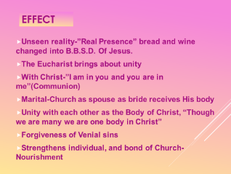

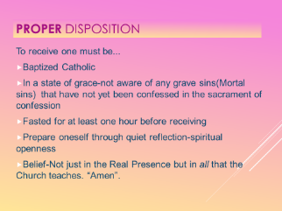 | CCC 1385 To respond to this invitation we must prepare ourselves for so great and so holy a moment. St. Paul urges us to examine our conscience: "Whoever, therefore, eats the bread or drinks the cup of the Lord in an unworthy manner will be guilty of profaning the body and blood of the Lord. Let a man examine himself, and so eat of the bread and drink of the cup. For any one who eats and drinks without discerning the body eats and drinks judgment upon himself."²¹⁸ Anyone conscious of a grave sin must receive the sacrament of Reconciliation before coming to communion.
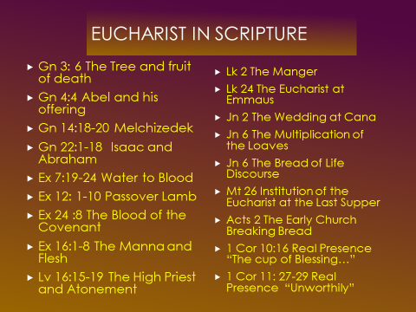 | - “The Eucharist is ‘the source and summit of the Christian life” (CCC 1324). More than any other sacrament, the Eucharist is located throughout the story of salvation. The Bible is soaked with typological and allegorical references to the Eucharist. It is important to not get bogged down on any one of them but rather to quickly hit them all from beginning to end. Students should have their Bibles ready because it is a fast paced journey from Genesis to Revelation. This could take two to three class periods. Starting with Creation and fruit of the tree in Eden we ask ‘What in this story is eucharistic?”
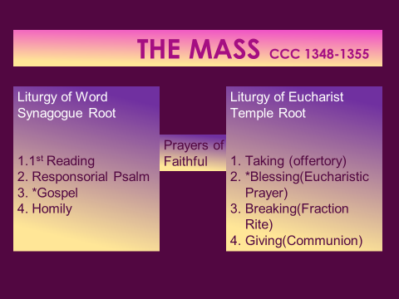 | The Mass of all ages  1345 As early as the second century we have the witness of St. Justin Martyr for the basic lines of the order of the Eucharistic celebration. They have stayed the same until our own day for all the great liturgical families. St. Justin wrote to the pagan emperor Antoninus Pius (138-161) around the year 155, explaining what Christians did:  On the day we call the day of the sun, all who dwell in the city or country gather in the same place.  The memoirs of the apostles and the writings of the prophets are read, as much as time permits.  When the reader has finished, he who presides over those gathered admonishes and challenges them to imitate these beautiful things.  Then we all rise together and offer prayers* for ourselves . . .and for all others, wherever they may be, so that we may be found righteous by our life and actions, and faithful to the commandments, so as to obtain eternal salvation.  When the prayers are concluded we exchange the kiss.  Then someone brings bread and a cup of water and wine mixed together to him who presides over the brethren.  He takes them and offers praise and glory to the Father of the universe, through the name of the Son and of the Holy Spirit and for a considerable time he gives thanks (in Greek: eucharistian) that we have been judged worthy of these gifts.  When he has concluded the prayers and thanksgivings, all present give voice to an acclamation by saying: 'Amen.'  When he who presides has given thanks and the people have responded, those whom we call deacons give to those present the "eucharisted" bread, wine and water and take them to those who are absent.¹⁷¹  1346 The liturgy of the Eucharist unfolds according to a fundamental structure which has been preserved throughout the centuries down to our own day. It displays two great parts that form a fundamental unity:  - the gathering, the liturgy of the Word, with readings, homily and general intercessions;  - the liturgy of the Eucharist, with the presentation of the bread and wine, the consecratory thanksgiving, and communion.  The liturgy of the Word and liturgy of the Eucharist together form "one single act of worship";¹⁷² the Eucharistic table set for us is the table both of the Word of God and of the Body of the Lord.¹⁷³  1347 Is this not the same movement as the Paschal meal of the risen Jesus with his disciples? Walking with them he explained the Scriptures to them; sitting with them at table "he took bread, blessed and broke it, and gave it to them."¹⁷⁴

