Curriculum, Effective Teaching, Challenges, Content - Presentation Notes

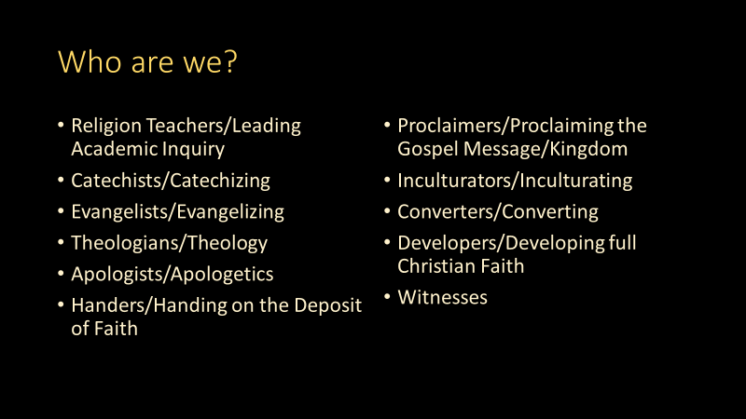 | GDC: The proper character of religious instruction in schools  73. Within the ministry of the word, the character proper to religious instruction in schools and its relationship with the catechesis of children and of young people merit special consideration.  The relationship between religious instruction in schools and catechesis is one of distinction and complementarity: "there is an absolute necessity to distinguish clearly between religious instruction and catechesis". (220)  What confers on religious instruction in schools its proper evangelizing character is the fact that it is called to penetrate a particular area of culture and to relate with other areas of knowledge. As an original form of the ministry of the word, it makes present the Gospel in a personal process of cultural, systematic and critical assimilation. (221)  In the cultural universe, which is assimilated by students and which is defined by knowledge and values offered by other scholastic disciplines, religious instruction in schools sows the dynamic seed of the Gospel and seeks to "keep in touch with the other elements of the student's knowledge and education; thus the Gospel will impregnate the mentality of the students in the field of their learning, and the harmonization of their culture will be achieved in the light of faith". (222)  - It is necessary, therefore, that religious instruction in schools appear as a scholastic discipline with the same systematic demands and the same rigour as other disciplines. It must present the Christian message and the Christian event with the same seriousness and the same depth with which other disciplines present their knowledge. It should not be an accessory alongside of these disciplines, but rather it should engage in a necessary inter-disciplinary dialogue. This dialogue should take place above all at that level at which every discipline forms the personality of students. In this way the presentation of the Christian message influences the way in which the origins of the world, the sense of history, the basis of ethical values, the function of religion in culture, the destiny of man and his relationship with nature, are understood. Through inter-disciplinary dialogue religious instruction in schools underpins, activates, develops and completes the educational activity of the school. (223)  - Vocation: This is a calling to a great adventure that only God can lead.  - Grace: You’re participating in the great project of the Apostles and must be a pliant instrument of the Holy Spirit.  - Baptized, Confirmed, Commissioned: You are in the Church. You are representing the Bishop, not self, not an impartial, unaffiliated teacher of ‘religious studies’. From the outside looking in like an objective journalist.  - Witness: You are the face of Christ. Embrace that responsibility but avoid Messianic complex.  - Catechesis in an academic setting: Teaching for Catholic Students to grow in their faith (fides qua) and be formed in the Faith (fides quae).  - Evangelization: Teaching for non-Catholic students to be introduced to the Gospel, to Jesus, to the Church. Evangelization is not coercion or indoctrination. To grow in their own faith and be formed. Proposing truth, revealing beauty, and demonstrating goodness  ​
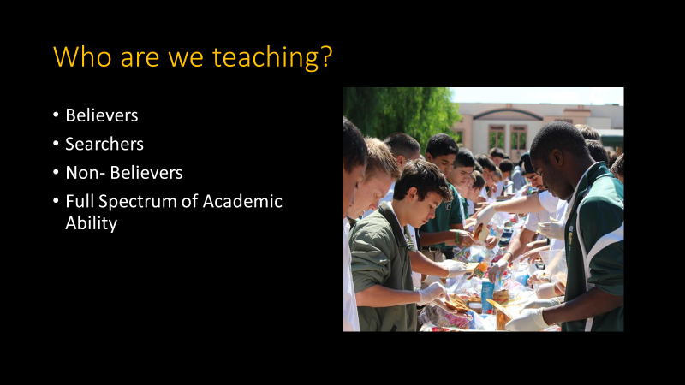 | GDC Ch 2, 75: In the case of students who are believers, religious instruction assists them to understand better the Christian message, by relating it to the great existential concerns common to all religions and to every human being, to the various visions of life particularly evident in culture and to those major moral questions which confront humanity today.  Those students who are searching, or who have religious doubts, can also find in religious instruction the possibility of discovering what exactly faith in Jesus Christ is, what response the Church makes to their questions, and gives them the opportunity to examine their own choice more deeply.  In the case of students who are non-believers, religious instruction assumes the character of a missionary proclamation of the Gospel and is ordered to a decision of faith, which catechesis, in its turn, will nurture and mature.  - RDECS # 6: Not all students in Catholic schools are members of the Catholic Church; not all are Christians. There are, in fact, countries in which the vast majority of the students are not Catholics - a reality which the Council called attention to. (6) The religious freedom and the personal conscience of individual students and their families must be respected, and this freedom is explicitly recognized by the Church.(7) On the other hand, a Catholic school cannot relinquish its own freedom to proclaim the Gospel and to offer a formation based on the values to be found in a Christian education; this is its right and its duty. To proclaim or to offer is not to impose, however; the latter suggests a moral violence which is strictly forbidden, both by the Gospel and by Church law.  ADLA Admin Handbook…  - (8)All students whether Catholic or non-Catholic are required to be enrolled in a religion course for a grade/credit each semester.  - As appropriate, schools may offer an introductory preparation class for students who have no experience with formal religious structures or vocabulary.  - Non-Catholic students participate in liturgies and other sacramental programs in a manner that respects their religious traditions and recognizes that they are not Roman Catholic.  - Should students from a non-Catholic background or who have no formal religious background express an interest in joining the Catholic faith, their parents/guardians must participate directly in the discussion and, as a general matter, any decision would be postponed until adulthood and after high school graduation.  (ADLA Admin Handbook)  - Opportunity to clarify so many misconceptions about Catholics and Catholicism.
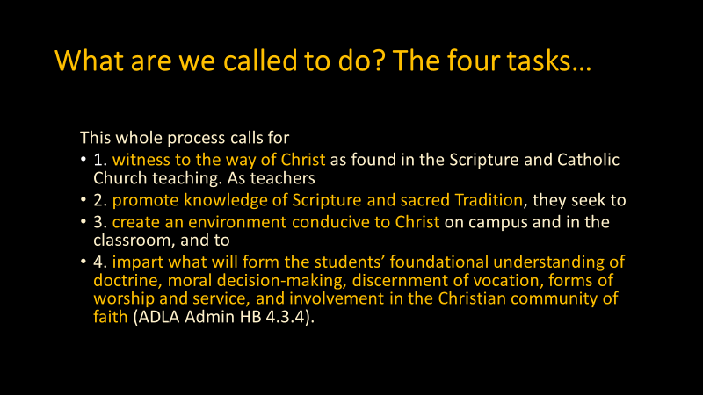 | - The goals of the religion program in the Catholic school is to provide an environment for students to…  - encounter Jesus Christ  - to form students in the Christian faith  - to provide students with the opportunity to learn about and experience the Church's teachings and practices in an academic setting. (ADLA Admin HB 4.3.2).
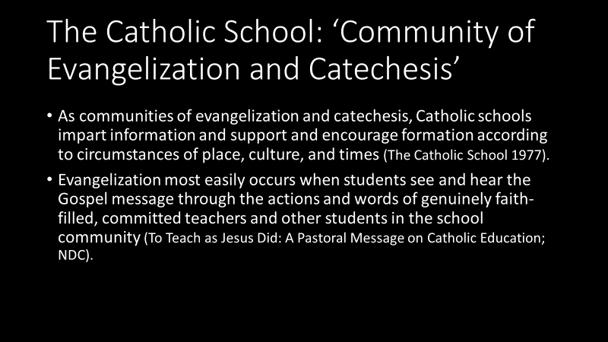
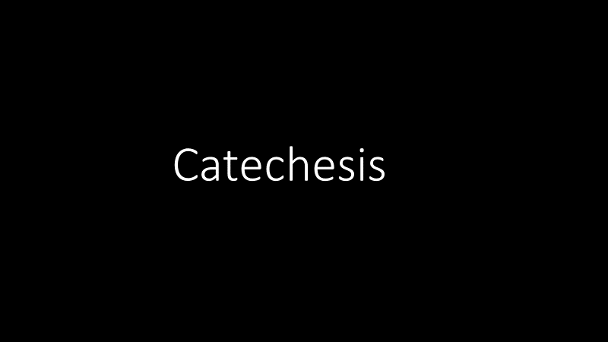
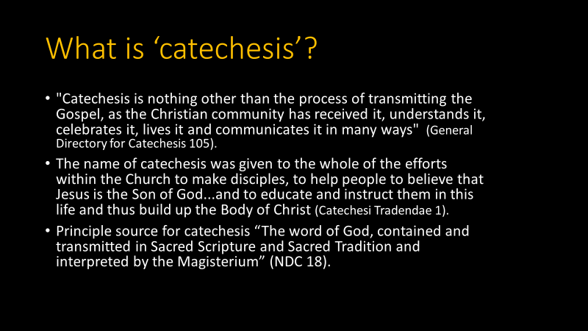
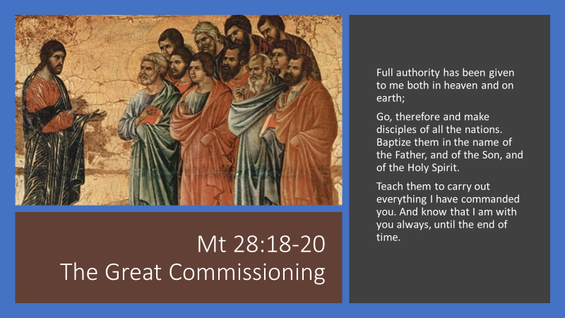 | - CCC 77- Catholic Bishops as successors to the Apostles inherit the mandate to be teachers of the flock and to preserve the Gospel.  - "In order that the full and living Gospel might always be preserved in the Church the apostles left bishops as their successors.  - They gave them their own position of teaching authority." Indeed, "the apostolic preaching, which is expressed in a special way in the inspired books, was to be preserved in a continuous line of succession until the end of time."  - Lay catechists and religion teachers are commissioned (certified) by the local Bishop.  - This great commission has been handed to women and men, whom God has called, to proclaim the Good News. This ministry of teaching and forming has traditionally been referred to as catechesis. Catechesis is a shared but differentiated responsibility. Bishops, priests, deacons, religious and lay persons play their part, each according to their respective responsibilities and charisms (General Directory for Catechesis (1998) #216).  - The entire Christian community should feel responsibility for this service (ibid #219).
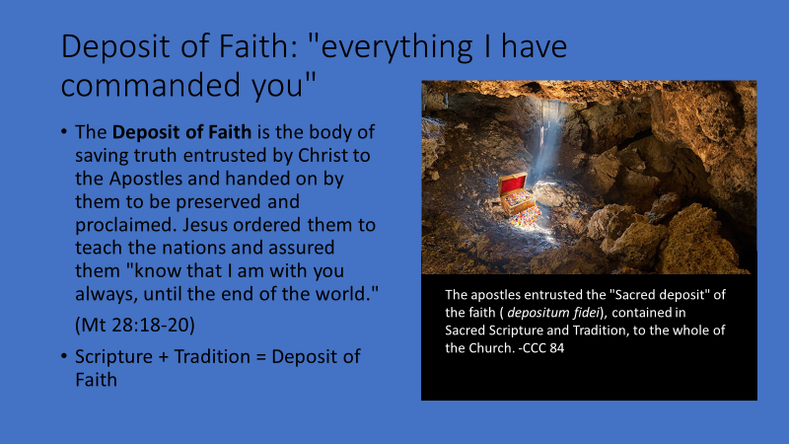 | - CCC 76 In keeping with the Lord's command, the Gospel was handed on in two ways:  - - orally "by the apostles who handed on, by the spoken word of their preaching, by the example they gave, by the institutions they established, what they themselves had received - whether from the lips of Christ, from his way of life and his works, or whether they had learned it at the prompting of the Holy Spirit";³³  - - in writing "by those apostles and other men associated with the apostles who, under the inspiration of the same Holy Spirit, committed the message of salvation to writing".  - This "deposit of faith" (298) is like the treasure of a householder; it is entrusted to the Church, the family of God, and she continuously draws from it things new and old. (299) All God's children, animated by his Spirit, are nourished by this treasure of the Word. They know that the Word is Jesus Christ, the Word made man and that his voice continues to resound in the Church and in the world through the Holy Spirit.  - Principle source for catechesis “The word of God, contained and transmitted in Sacred Scripture and Sacred Tradition and interpreted by the Magisterium” (NDC 18).  - "Catechesis will always draw its content from the living source of the word of God transmitted in Tradition and the Scriptures, for sacred Tradition and sacred Scripture make up a single sacred deposit of the word of God, which is entrusted to the Church“ (GDC 94).
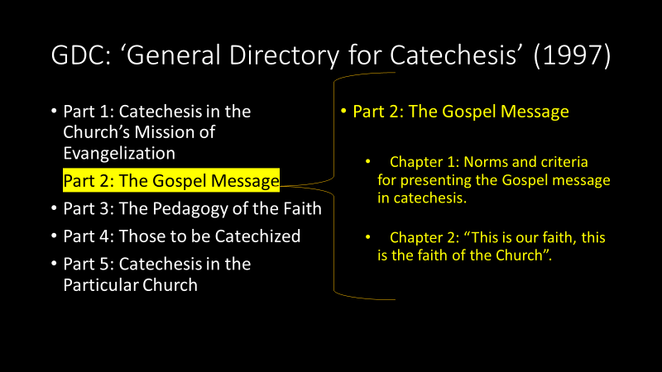
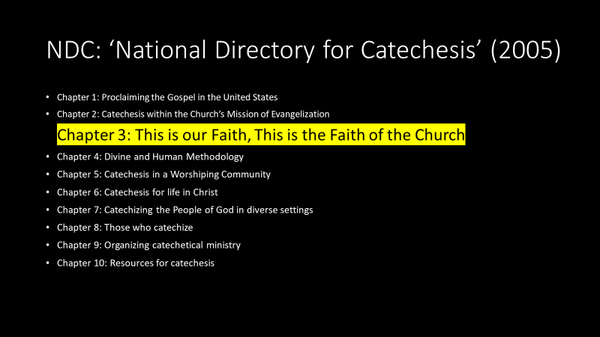
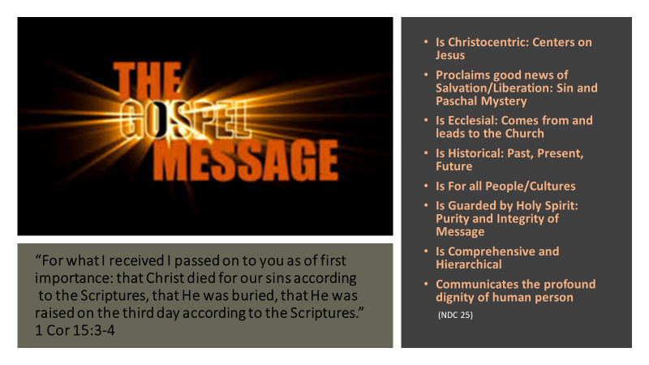 | - Explain Kerygma
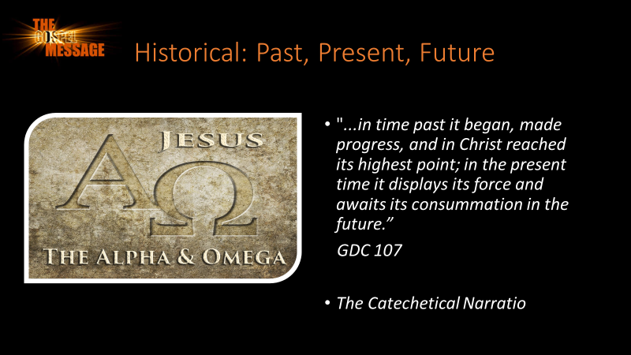 | - Dr. Peter Kreeft is fond of saying “there are two things that never get boring, the great stories and other people.” The story of Salvation History is far and away the most engaging way to instruct beginners and the seasoned faithful alike. The story conveyed by the catechetical narratio is the ultimate story and it elucidates the lives of the most interesting people in history, not to mention the life of God incarnate, our Lord and Savior Jesus Christ who Himself uses stories to convey many of His most important teachings.  - A very ancient and time-honored way of presenting the Gospel is to tell The Catholic Family Story. This is the story of who God is and what his plan is for us. The story should be told - in its entirety - near the very beginning of the catechumenal process. This can be accomplished in thirty minutes. The catechist simply lays out the story, element by element, beginning with God, continuing to the present day, and following all the way to the last things: death, judgement, Heaven, and Hell.  - Trinity and Creation - God is Trinity and creates out of his divine love  - Divine Revelation - God speaks to us so we may know his will  - Man and Woman - We are made in the image of God (Lat. Imago Dei)  - Sin - We have separated ourselves from God through our own free will  - From Adam to Jesus - God has been working to save us through the covenants  - Jesus Christ - In the final and definitive covenant, God became man!  - Paschal Mystery - Jesus saves us through his Suffering, Death, Resurrection and Ascension into Heaven!  - Pentecost - Jesus sends the Holy Spirit; the Church is born  - Life in Christ/Sacraments - Jesus frees us from our sin and brings us true joy in holiness  - The 4 Last Things - We will die and be judged; heaven and hell are the only two final destinations for every human person  -----------------------------  - -Framework course one, five: Salvation History.Sacraments.
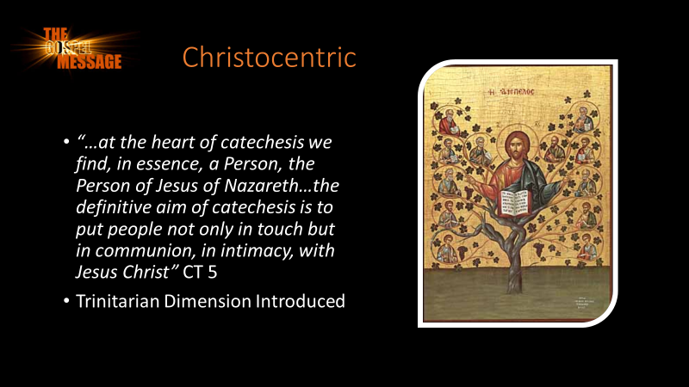 | - Framework course 2 & 3 :Christology/PM
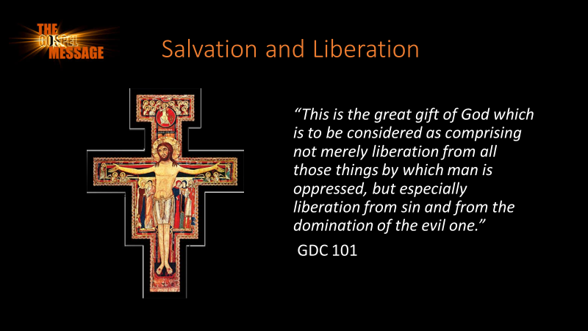 | Course 2:PM
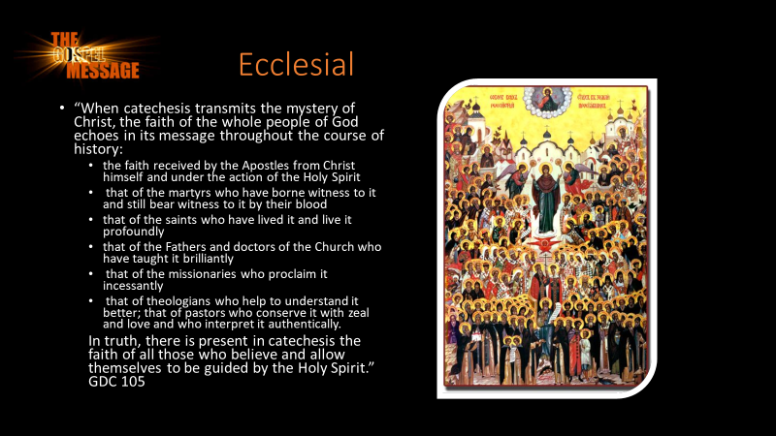 | Course 4: Ecclesiology  Vat 2: Lumen Gentium
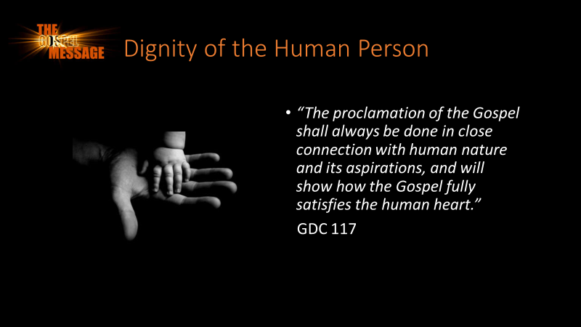 | Morality and Social Teachings
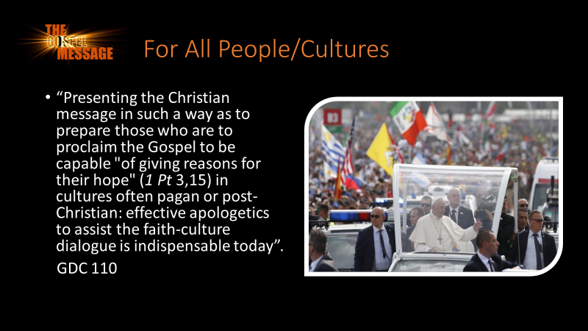
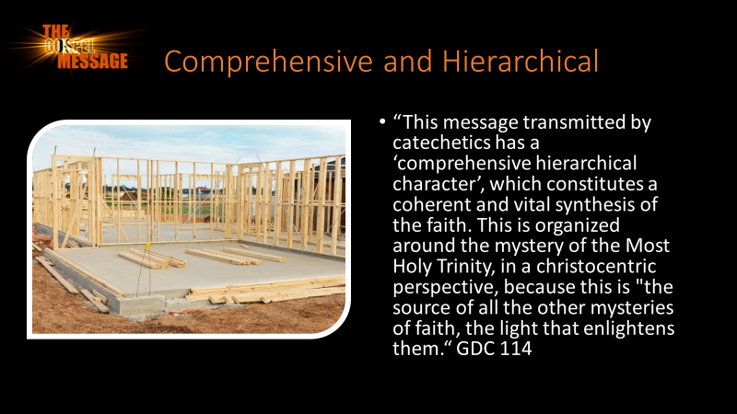
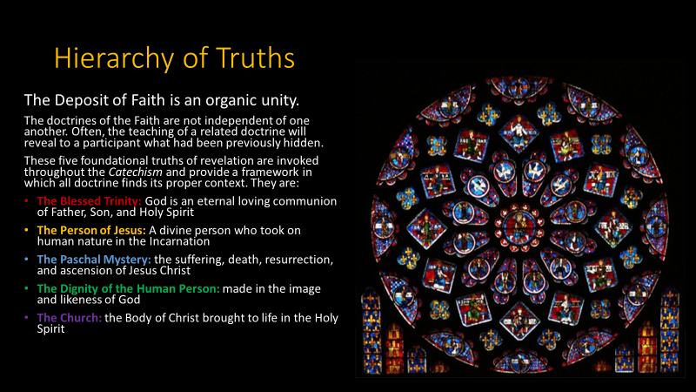
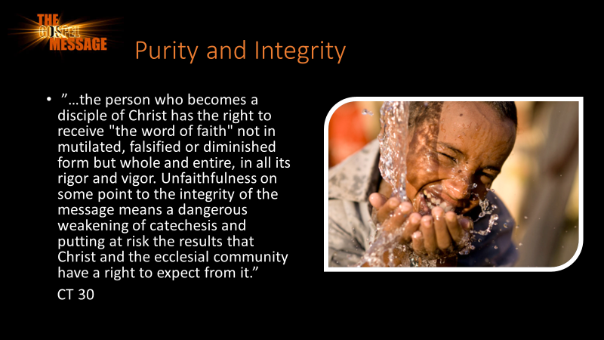
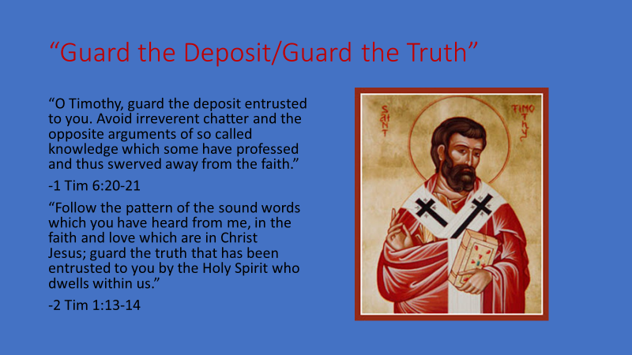 | - the catechist who understands the deposit the way I have described it here should be humbled by it. He should know now that what he hands on to others is not his own teaching but the teaching of Christ. He should entreat the Holy Spirit to guide him in his delivery of the Gospel, since the Holy Spirit was given to the Church for this very purpose. Finally, he should guard this deposit as if it were a “treasure,”[15] and not let it be corrupted by “godless chatter.”[16]  - “The precious deposit” JPII
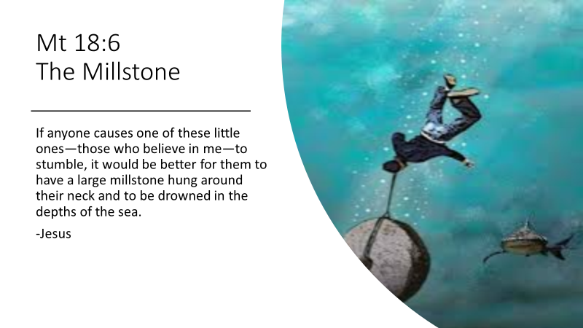
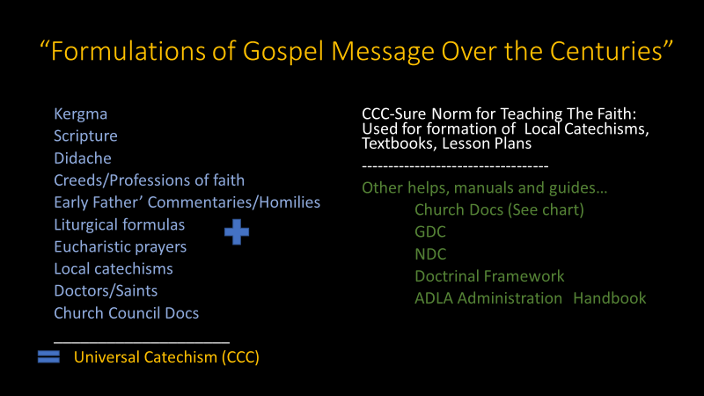
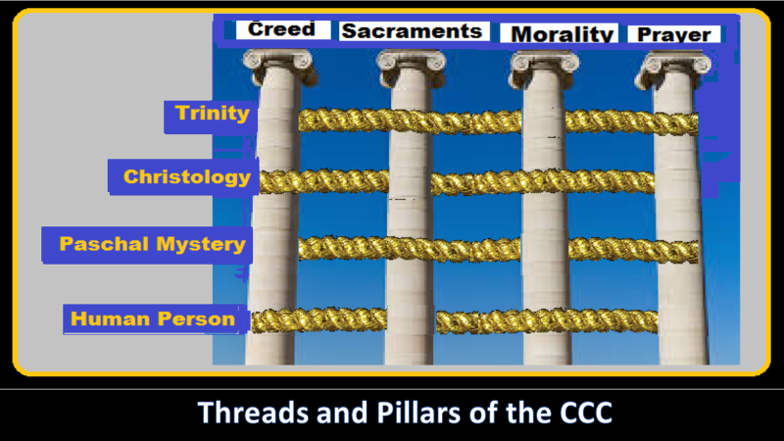 | The four parts are related one to the other: the Christian mystery is the object of faith (first part); it is celebrated and communicated in liturgical actions (second part); it is present to enlighten and sustain the children of God in their actions (third part); it is the basis for our prayer, the privileged expression of which is the Our Father, and it represents the object of our supplication, our praise and our intercession (fourth part).  The Liturgy itself is prayer; the confession of faith finds its proper place in the celebration of worship. Grace, the fruit of the sacraments, is the irreplaceable condition for Christian living, just as participation in the Church's liturgy requires faith. If faith is not expressed in works, it is dead (cf. Jas 2:14-16) and cannot bear fruit unto eternal life.
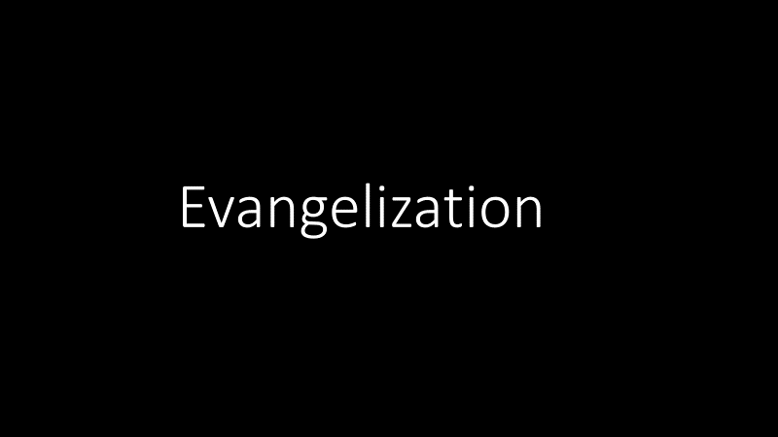
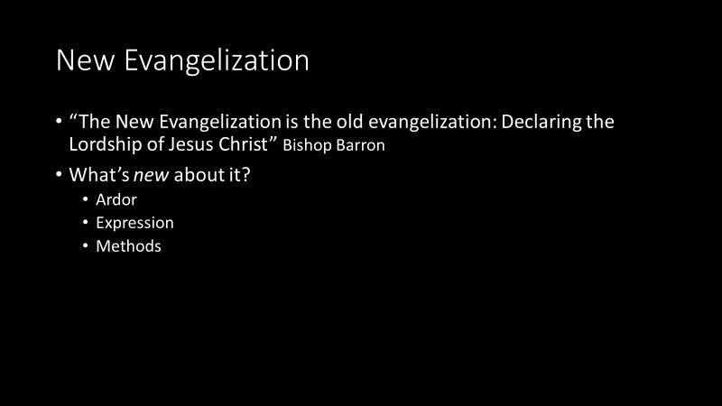
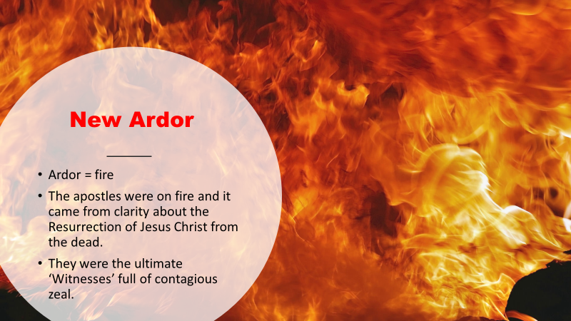
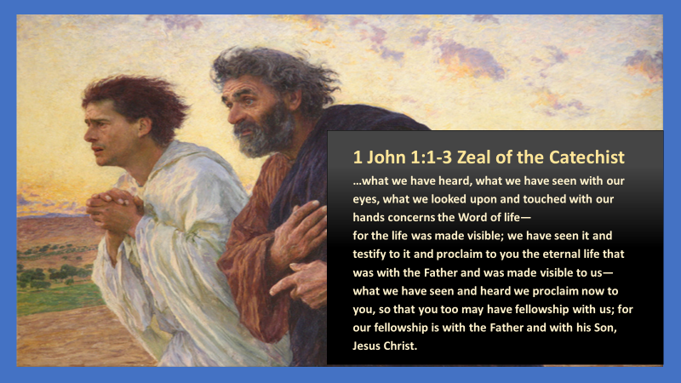
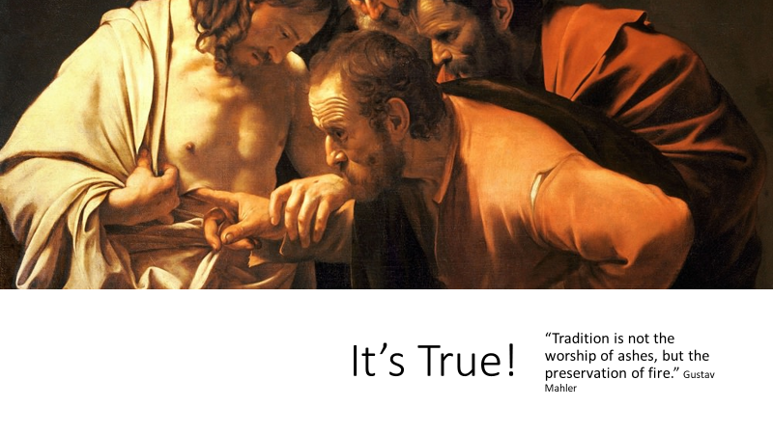
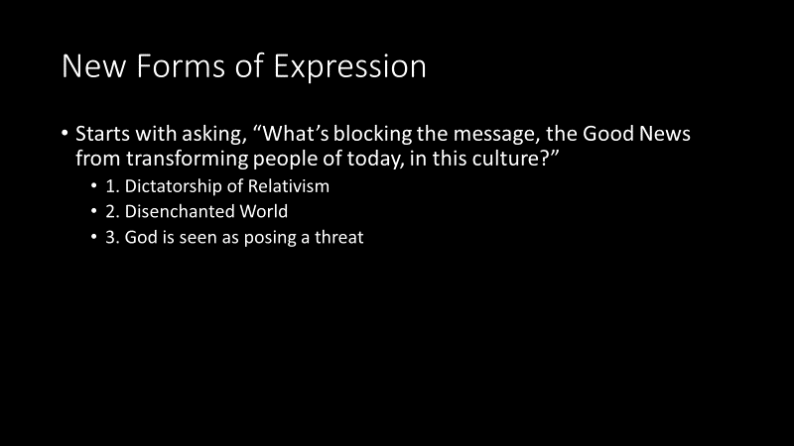 | - 1.Disenchanted World says our ultimate fulfillment is in seeking power, possessions, prestige and pleasure. Secularism suppresses the hunger for God.  - COUNTER: “Our hearts are restless of God until they rest in you.” St. Augustine  - 2.God Poses a threat to human flourishing and happiness. “The no to God is yes to man” Ludwig Feuerbach. “If God exists I cannot be free” Friedrich Nietzsche  COUNTER: “The glory of God is a human being fully alive”. St. Irenaeus
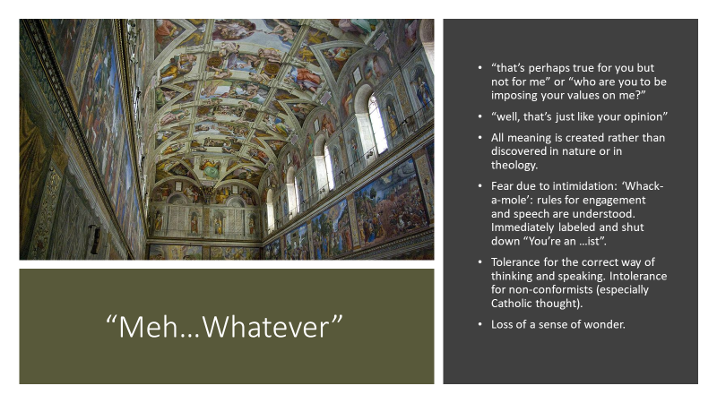
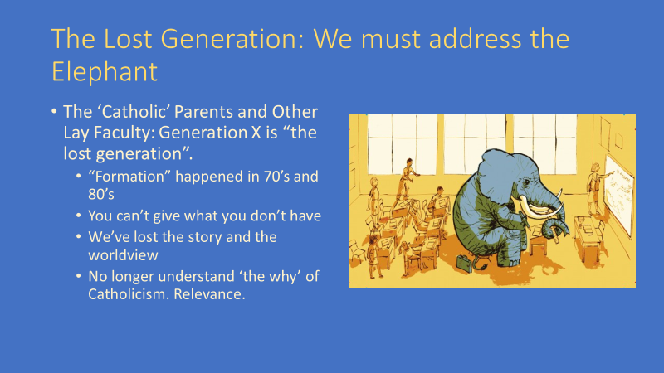
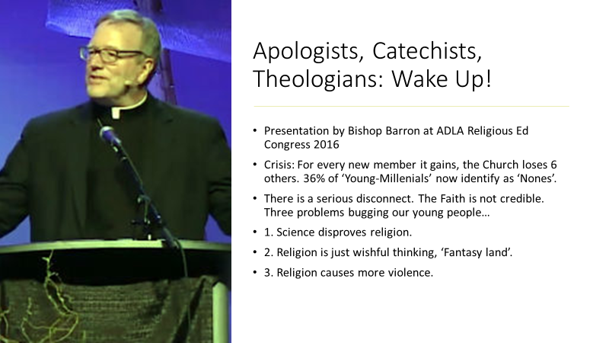
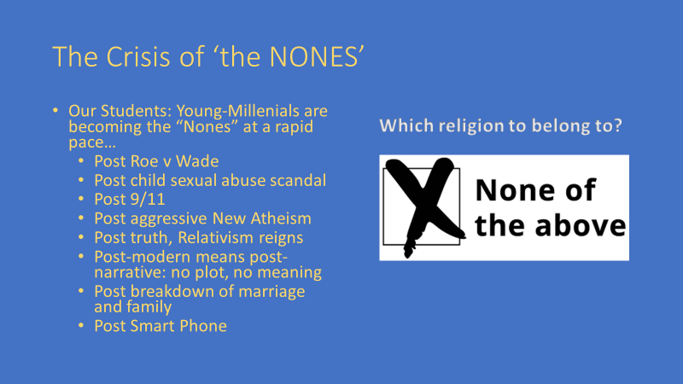
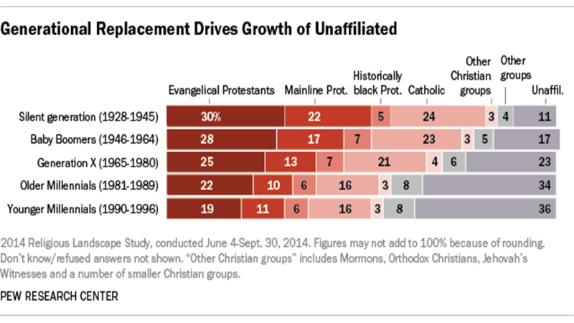
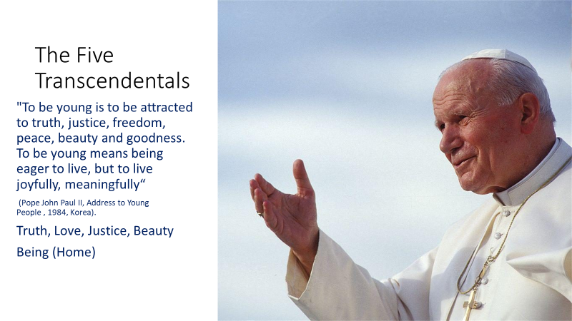 | Philippians 4:8 -“Finally, brethren, whatever is true, whatever is honorable, whatever is just, whatever is pure, whatever is lovely, whatever is gracious, if there is any excellence, if there is anything worthy of praise, think about these things.”
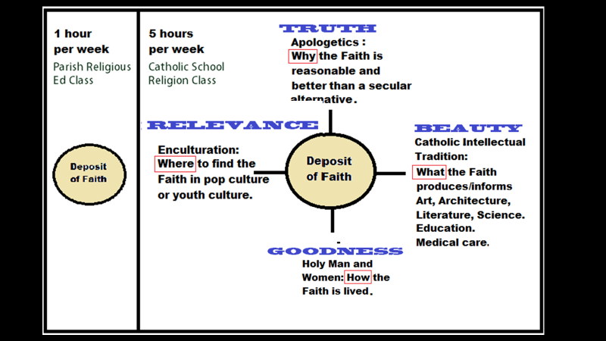
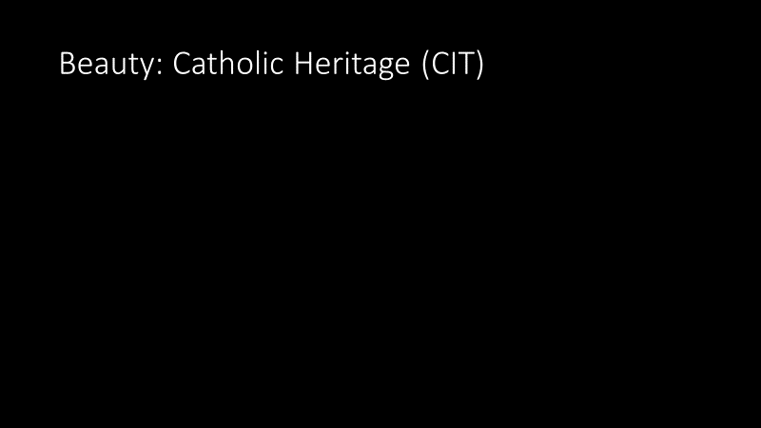
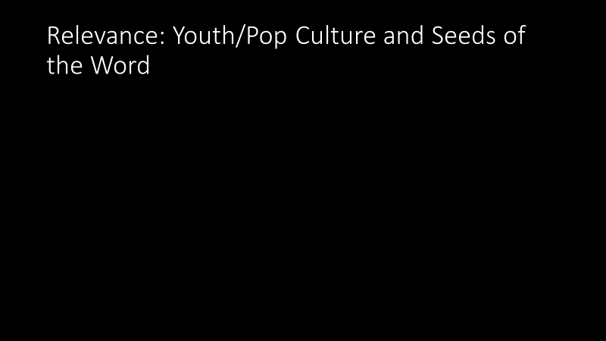
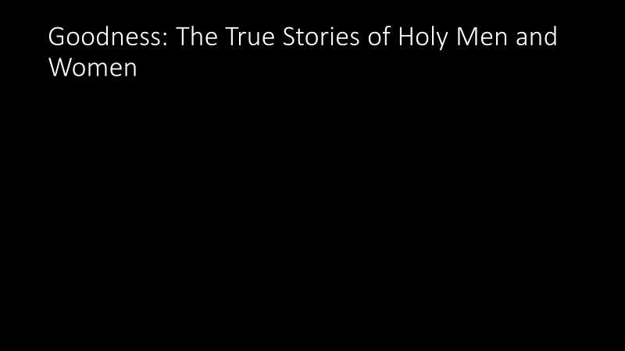
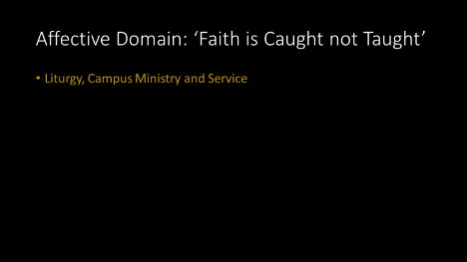
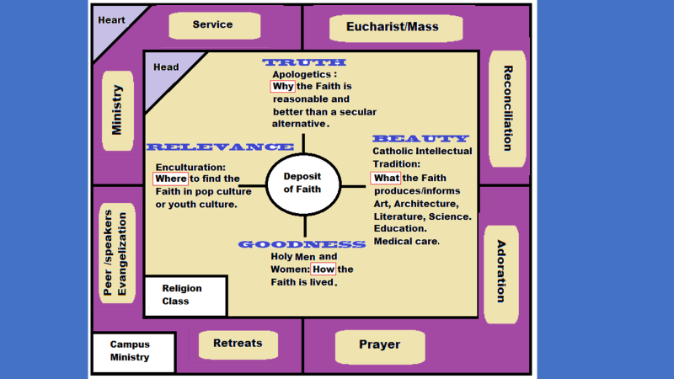 | Cognitive Domain  Affective Domain
