Fleshing out the Framework: Unit Plans

Before, when the doctrinal framework came out, we understood that it was kind of like the skeletal framework or the bone of the whole curriculum. Through the use of a variety of resources and methods-we, as the teachers, are left to ‘flesh out’ the lesson plans. This analogy seems to have sunk in but it was left there-incomplete. To carry this analogy a step further I created the diagram below titled, ‘DHS Theology Lesson Plan Cross-section’.
If the bone is the framework, then what about the ligaments, muscles, arteries, nerves epidermis etc.. Though we all might have different ways to answer this, I think it is a valuable thought experiment.
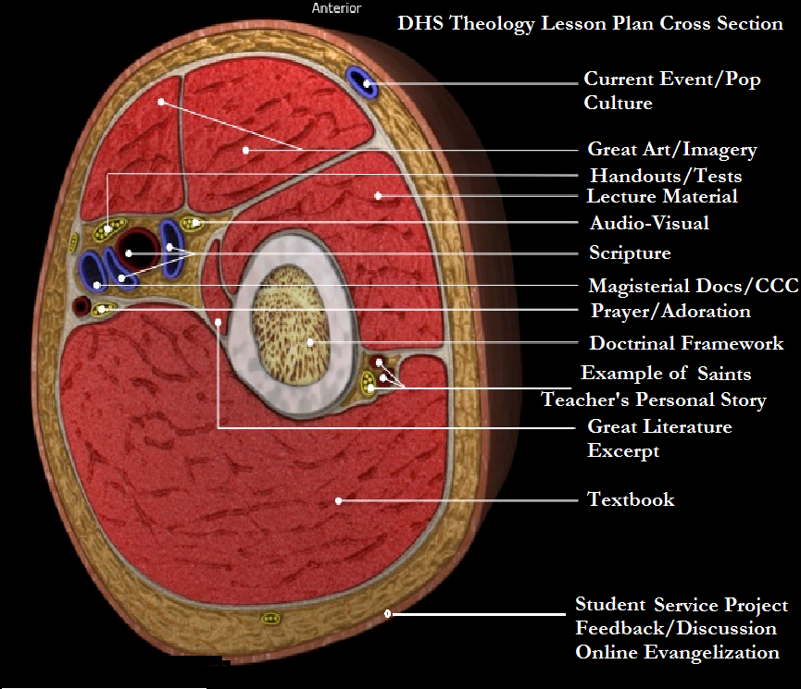
Mine though experiment unfolded in this way…As we have said the bone is the Framework. If that is true then the marrow of that bone must be the Catechism of the Catholic Church. I think the textbook would be the tri-cep muscle because it works in close proximity and conjunction with the framework. The arteries would be the Scriptures because they should incessantly feed the students with the nutrients and oxygen of the life-giving Word of God. The nerves would be the spiritual part of our class that gives the lesson plan a deeper sensation or contact with the holy. This would be opening prayers, lectio-divina, prayer-services, meditations, liturgical calendar and adoration. The next largest muscle (bicep) would be lecture material in our power-points, presi, white board etc.. Great art, imagery and music to look at, listen to, analyze, meditate with or simply appreciate would be the two smaller muscles that coordinate with the main muscles. They help to pull the arm in a different direction than the textbook while maintaining the central theme of the ‘unit plan’. By ‘unit plan’ I mean a whole theme drawn from a section of the Bishop’s outline. Unlike a daily ‘lesson plan’, a unit plan is one to two weeks of working on a big idea or theme.

Current events and pop-culture are a secondary source of intake from the culture we live in (specifically adolescent culture) because this also shapes who are students are becoming for good or for bad so they are the other main artery. We take what is relevant in pop-culture and show or extract the traces of the good, beautiful or true. What does it say about God or the Faith as a whole or to this particular topic?

The example of the saints and role-models are smaller nerves and veins because they also awaken a sense of what possible when real people live this teaching out in time and space and not just in theory or idea form. In sharing our own experiences as a witness of Christian living and in examining the lives of saints and other role-models-we are showing our students how to move from the general, abstract and philosophical to the concrete and incarnational.

The epidermis is concerned with external application of the teaching. Since we teach for both understanding and change we ask, ‘How has this changed their way of living out the Faith’? Can they articulate their own conviction or give an account for the hope that they place in this teaching? How will this teaching affect the way they interact with immediate people around them and also how they present themselves to the world as a whole which they can contact online, social media, blog, podcast, discussion forums etc.. This epidermis is naturally the first thing people see from the outside. When our students experience service toward others (service-learning) those being served are built up in faith by this external act of love.

So to have with all or at least most of the essential components (The bones arteries, nerves muscle skin etc.) that constitute a completely healthy and whole lesson plan I think we should create the lesson on an entire unit. The entire cross section or unit would necessarily take several days to explore all the parts. As an example I would submit the following unit plan on one part of the curriculum for Theo III. So if you cut the arm into a one inch section it would still have all the parts just like the diagram. If a one inch section represented a whole week where would we begin? 1. Locate which section of the Framework you are covering. Read through the CCC citations for that section. 2. Locate which part of the textbook corresponds. Read through the student text. 3. Identify the foundational or driving scripture passage related to this teaching. You can do this in two ways. List the scripture citations from the textbook and or use the CCC to locate which scriptures are foundational to that topic, unit and theme.

These scriptures should be read, studied and incorporated into prayer throughout the unit. I have two ways that I generally do this… to spread them out in daily Bible warm-ups and use them in your PPT presentations. The Bible warm up is on the board. The students read silently. The students locate three key words and write them down. A different student each day gets up to the podium and reads it aloud while the other students follow along and read it a second time. This is followed with a prayer led by the student who reads that day. I may or may not open the class by commenting on the scripture. Sometimes I leave it to speak for itself or as a seed that has been planted that the other material covered in that unit will help to develop. These daily Bible warm ups help make the class scriptural, spiritual and quasi-liturgical. In addition to this it affords each student an opportunity to be an evangelist and spiritual leader before his peers. The time used for these Bible-warm ups and opening prayer amounts to about five minutes. This time would otherwise be wasted as I have to take roll anyway. It helps to settle the students down and put them in study mode as soon as the bell rings.

Preparation Steps 1-3…

- ‘The Bone’ | USCCB Doctrinal Framework. (Theo IIIB Section I. B.)  B. Our response to God’s plan.  1. Response of love (CCC, no. 1828).  2. He calls us to beatitude or joy.  a. The Beatitudes (CCC, no. 1716).  b. Effects of the Beatitudes (CCC, nos.  1718-1724).  c. God’s gift of joy (CCC, no. 1720).
- ‘The Arteries’ | Mt 5:3-12, Mt 4:17, Mt 7:13-14, Lk 6:20-23,  1 Cor13:12, 2 Pet1:4, Gal 2:19-20, Jn 17:3, Rm 8:18, 1 Cor 7:29-31, Lk 4:1-13
- ‘The Muscle’ | Part 1, Article 3 “New Life in Christ’ Pgs. 18-22.

The next part of the preparation for the unit plan is to locate the general theme. In this case the theme is ‘Beatitudes-True happiness and detachment’. Once you have completed these three steps then move on to create the unit plan day by day. Each day should build on the day before. Each day the plan should be on the white board in bullet points. These are the questions I ask…

- What art work relates to this theme?
- How does it relate to Liturgy?
- What video support teaches this lesson or relates to the theme?
- How can I connect this theme to their everyday life or the culture as a whole?
- What personal story can I share that teaches about the theme?
- How can I get the students to present this theme back to me in a way that demonstrates understanding and change?
- Are there any service opportunities that this theme can be connected to?
- Are there any literature excerpts, poems or short stories, prayers that highlight this theme?
- What Saint or role models relate to this theme of true happiness and detachment?

Sample Unit Plan…
The Beatitudes and True Happiness | List of Items that we do or cover. Each day these are listed for students on white board.
Monday  (Scripture, Prayer, Liturgy, Art, Music, Textbook) | - Bible Warm Up : Mt 5:3-12  - The Beatitudes-Nov1 All Saints (Liturgical Calendar). The Saints are Happy.  - Introduce theme: Happiness and Paradox  - Great Art Meditation; Isenheim altarpiece, painted by Matthias Grünewald (1512–1516). Set to Litany of Saints in Latin.  - Overview of Vocabulary  - Textbook. Read and Review Questions for HW
Tuesday  (Scripture, Prayer, Video) | - Bible Warm Up : Gal 2:19-20  - Fr. Barron Catholicism Episode 2, ‘ Happy Are We’
Wednesday  (Scripture, Prayer, notes, video clip: Pop Culture, personal story, handout, online component)) | - Bible Warm Up :Mt 20:25-28  - Intro to the 4 p’s Possessions, power, prestige and pleasure as sources of ‘happiness’-PPT  - Tom Brady Video clip, ‘There has to be more’.  - Share personal story about the 4 P’s in my life and true happiness.  - Handout: Beatitudes and True Happiness. Create a chart linking Beatitudes with corresponding  - Essay Questions on Moodle- for HW.  - virtues. Link Beatitudes that require detachment from the 4 P’s.
Thursday/Friday (Block)  (Scripture, Prayer, Notes, Creative Activity, Peer Evangelization) | - Bible Warm Up : 1 Cor 7:29-31  - Finish PPT: Beatitudes and Happiness  - Group Activity. Culture/Current event-Locate 4 p’s in magazines. Create a 4p’s poster.  - Present posters
Monday  (Scripture, Prayer, Video: Biography of a Saint, Handout) | - Bible Warm Up : Lk 4:1-13  - Blessed Charles de Focauld: Example of Radical Detachment from the 4 p’s. Life of Beatitude. Fulton Sheen tells his story/handout
Tuesday  (Scripture, Prayer, Assessment) | - Bible Warm Up : Lk 6:20-23  - Quiz on notes: “Beatitudes and True Happiness’

