Presentation 1: Introduction to Sacraments

Slide | Notes
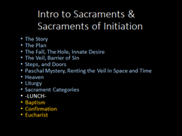 | Presentation I: ‘Intro to Sacraments’: CCC 1066-1209 (143 paragraph)
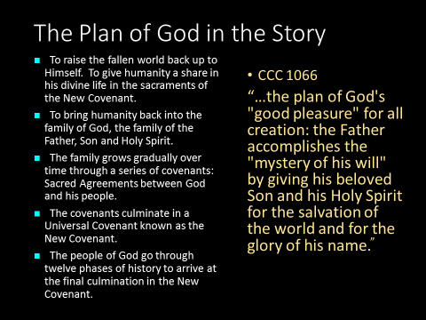 | THE CELEBRATION OF THE CHRISTIAN MYSTERY  Why the liturgy?  1066-1067 In the Symbol of the faith the Church confesses the mystery of the Holy Trinity and of the plan of God's "good pleasure" for all creation: the Father accomplishes the "mystery of his will" by giving his beloved Son and his Holy Spirit for the salvation of the world and for the glory of his name.¹  Such is the mystery of Christ, revealed and fulfilled in history according to the wisely ordered plan that St. Paul calls the "plan of the mystery"² and the patristic tradition will call the "economy of the Word incarnate" or the "economy of salvation."  1067 "The wonderful works of God among the people of the Old Testament were but a prelude to the work of Christ the Lord in redeeming mankind and giving perfect glory to God. He accomplished this work principally by the Paschal mystery of his blessed Passion, Resurrection from the dead, and glorious Ascension, whereby 'dying he destroyed our death, rising he restored our life.' For it was from the side of Christ as he slept the sleep of death upon the cross that there came forth 'the wondrous sacrament of the whole Church."'³ For this reason, the Church celebrates in the liturgy above all the Paschal mystery by which Christ accomplished the work of our salvation.  1079-1081 From the beginning until the end of time the whole of God's work is a blessing. From the liturgical poem of the first creation to the canticles of the heavenly Jerusalem, the inspired authors proclaim the plan of salvation as one vast divine blessing.  From the very beginning God blessed all living beings, especially man and woman. The covenant with Noah and with all living things renewed this blessing of fruitfulness despite man's sin which had brought a curse on the ground. But with Abraham, the divine blessing entered into human history which was moving  toward death, to redirect it toward life, toward its source. By the faith of "the father of all believers," who embraced the blessing, the history of salvation is inaugurated.  The divine blessings were made manifest in astonishing and saving events: the birth of Isaac, the escape from Egypt (Passover and Exodus), the gift of the promised land, the election of David, the presence of God in the Temple, the purifying exile, and return of a "small remnant." The Law, the Prophets, and the Psalms, interwoven in the liturgy of the Chosen People, recall these divine blessings and at the same time respond to them with blessings of praise and thanksgiving.
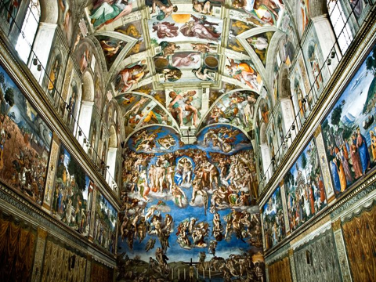 | - The Story CCC 1066, 1079-1081  - From Creation to end of time. It is a continuum.  - 15 min, 2 hours.  - Every year in instruction they need to be told the story.  - Present it as the Truth. “True Story’.  - Must always include: Incarnation, Paschal Mystery, Life of Church today (Hist of Church, Current pope, current bishops, recent saints,  - Issue Invitation: ‘ you are in this story to IF YOU CHOOSE TO BE’  - Telling the Story changes people.  - The story from which all other stories that are true take their strength.  - Context-Bookshelf for all teachings,1st in framework  - Biblical: Big Picture approach was Example of Stephen in Acts Ch 7
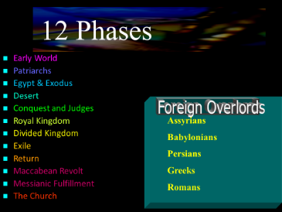  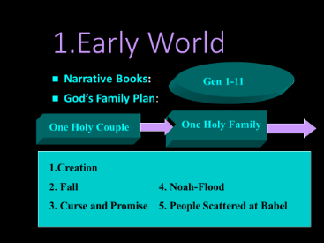  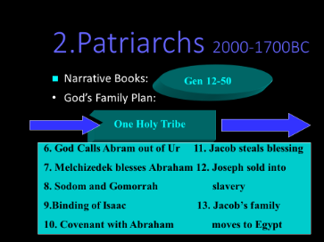  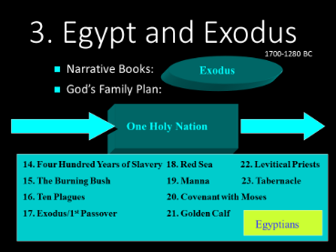  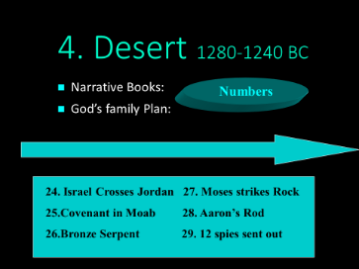  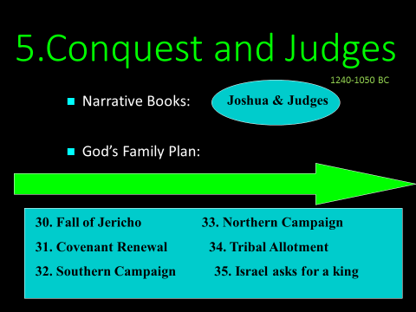  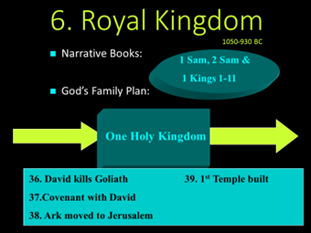  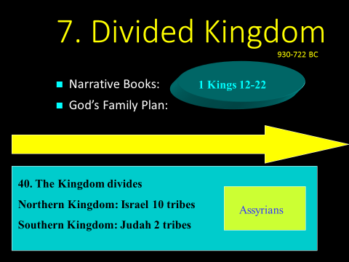  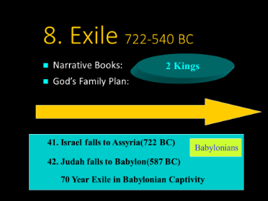  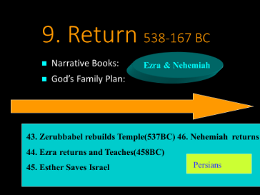  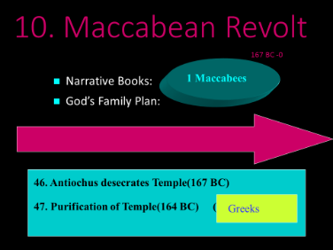  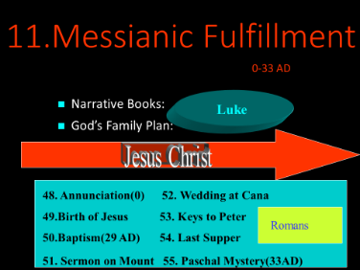  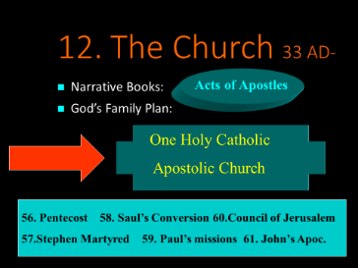  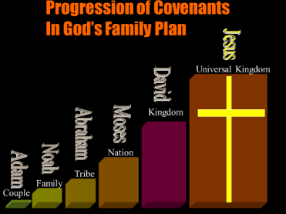  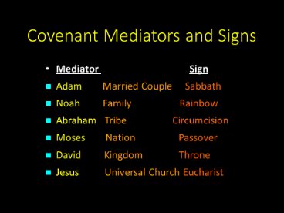  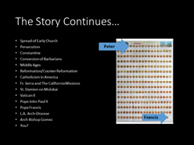 | Since the Junior students already have that foundation of the Story in freshmen year, for the Sacraments class, I spend one of our first days telling the story from beginning to end. It goes something like this…  ------In the beginning God created the world out of nothing. He created everything good. The pinnacle of his creation, our first parents, were placed in a lavish garden in God’s presence. He gave Adam and Eve, who were created in his image, a command to not eat of the tree in the middle of the garden. Eve was tempted by the serpent to eat of the fruit. She gave some to Adam. In choosing to disobey God, They brought upon themselves exile and banishment from the garden. That original sin brought about pain, suffering and death. To this day we are all born with a hole in our hearts, because we are missing what we should have had. God showed that he still loved them. God promised to send a savior who would crush the head of the serpent and reverse the effects of sin.  The ‘sin disease’ spread rapidly. It began with fratricide, the murder of Abel by his brother Cain. Later God told Noah that the world had become so wicked that he wanted to start over. He saved Naoh and his family from the devastating flood. The rest of the Bible tells how God went about to fulfill His promise by entering into a series of covenants. Covenants are sacred pacts or agreements between God and his people.  Beginning with Abram, God entered into covenant with his people and made promises. To Abraham he promised descendants, land and a universal blessing. God changed his name to Abraham, the father of nations. As a sign that God would fulfill his promise he gave Abraham a miracle child Isaac. His name was Isaac which means laughter because his mother, the barren old lady, Sarah laughed when she heard God’s plan. Isaac had two sons Esau and Jacob. The younger son, Jacob, tricked his father Isaac to give him the family blessing. Later Jacob wrestled with an angel and then God changed his name to Israel which means ‘he who wrestles with God’. Israel had twelve sons. The youngest son, Joseph was his favorite. Joseph told his brothers about a dream he had. In it they bowed down to Joseph. The brothers were jealous and sold Joseph into slavery in Egypt. Joseph interpreted the dreams of the Pharaoh and rose to become his right hand man. When a famine hit the land the sons of Joseph migrated to Egypt and reunited with their brother whom they failed to recognize. Joseph revealed himself and forgave his brothers. The sons of Israel and their families became known as the Israelites. They lived in Egypt and prospered.  The Israelites, the twelve tribes of Israel, grew so numerous and so strong that the pharaoh who came later became afraid of them and ordered that they be enslaved. He ordered that the first born males be killed. Moses, a Levite, was a male baby that was saved from this edict by being put in a basket and floated down the Nile. He was adopted by Egyptian royalty and grew up in the pharaoh’s court. When he was an adult he killed an Egyptian and was exiled from the land. He went to the land of Midian in the Sinai wilderness and there he encountered an angel and a burning bush. God spoke to him and revealed His name ‘Yahweh’, the God of Abraham Isaac and Jacob. He commissioned Moses to go back to Egypt and set his people free from bondage. At first Moses tried to get out of it but God insisted. Moses returned to Egypt and with God’s supernatural help he liberated the Israelites through ten plagues. During the tenth plague, the death of the first born, Moses smeared lambs blood on the doors of the Israelites. As they waited inside, eating the Passover meal, the angel of death swept across the land and killed the first born Egyptians but he ‘passed over’ the houses of Israel. The next day Moses led the Israelites in the exodus from Egypt. They crossed the Red Sea and the sea swallowed up the Egyptians who pursued them.  Moses took them back to Mt. Sinai, where he encountered God again and received the Ten Commandments. When Moses came down the mountain he saw that Commandment number one was being broken with the worship of the golden calf. This led to an ordained priesthood of the Levites. Moses and the Levites built an ark, an earthly, chest-like throne for God. They built a portable temple, the Tabernacle, as well. God dwelt with his people in the desert for forty years. The Heavenly Father provided Manna, water and quail for his people. Before Moses died he commissioned Joshua to be the spiritual and military leader of the Israelites.  Joshua led the Israelites into the Promised Land, modern day Israel. After they crossed the Jordan River, they encircled Jericho and the walls collapsed. They went on to take over all of the land by force and with God’s help. Spiritual leaders called ‘Judges’- people like Jephthah, Deborah and Samson ruled over the people and called them to avoid the Israelites’ bad habit of falling into worshiping false Gods.  After a while the people asked Samuel to anoint for them a king. They wanted to be like the nations that surrounded them. Samuel anointed Saul. Saul became a bad king. After Saul, Samuel anointed David. David had already proven his worthiness by smiting Goliath. David’s kingdom was strong and he wanted to build a temple for God in his new capital, Jerusalem. David died and Solomon, his son took over as king. Solomon was known for his wisdom and his leadership. The kingdom expanded and Solomon built the first temple in Jerusalem. When Solomon died the Kingdom split in two. The Northern tribes fought the southern tribes. The Assyrians and then Babylonians conquered the land. This led to the deportation and exile of the Jews of the ancient Kingdom of Judah to Babylon by Nebuchadnezzar II. The temple was destroyed. During this exile much of the Old Testament was written down and the synagogue style of worship took hold.  When the Persians defeated the Babylonians they allowed the Israelites to return to the land and to rebuild. During this time a beautiful heroine arose named Esther and she saved her people from an evil man who wanted to destroy all the Jews.  When the Greeks conquered the Persians they forced the Jews to become like them through hellenization and intermarriage. When an evil ruler, Antiochus Epiphanes desecrated the Temple the rebel band of Jews called the Maccabees engaged in guerilla warfare and defeated the Greeks. They went in and cleaned up the Temple and lit the lamps with the last bit of oil. Miraculously they burned for eight days. This is why the Jews celebrate Hanukkah (re-dedication) with an eight branched menorah.  Jews had self-rule for a while until the Romans came. During this Messianic period of hope, the Romans inserted a puppet king named Herod to rule on their behalf. He collected taxes from the Jews and stationed troops in Jerusalem. God sent the angel Gabriel to a young woman in Galilee named Mary. The angel announced God’s plan for Jesus the promised Messiah to be born. Mary said Yes! Like the evil pharaoh before him, Herod ordered the death of the first born baby boys. Jesus, after his birth in Bethlehem, was taken to Egypt to be saved from this slaughter.  When Jesus was an adult he was baptized by his prophet cousin John in the Jordan River. He went off to the desert for forty days to prepare for his mission of salvation. When he returned he performed his first miracle at the Wedding at Cana. The water turning to wine signified what he was about to do for the whole world. He called twelve apostles with Peter, the rock as their future leader. Jesus performed miracles of nature , healing miracles and exorcisms. He taught the people God’s will and he promised to prepare a place for them in heaven. When Jesus was preparing for death at the Last Supper, he gave the Church the priesthood and the Eucharist. The next day he gave his life as a sacrifice of pure love on the cross.  Three days later he rose from the dead and appeared to many people. By rising from the dead he proved that He was the divine messiah who reversed the effects of sin. In defeating the power of sin, Jesus fulfills the promise of crushing the head of the serpent. Forty days later he ascended into Heaven. Ten days later the Holy Spirit came to the Apostles and Mary in the upper room. They were transformed into the mystical body of Christ. This was the birthday of the Church.  The Church leaders gathered for the Eucharist and lived in harmony and love with each other. They eagerly anticipated Jesus return and the final judgment. As time went on the Apostles spread out across the known world to spread the Gospel message. They established the church in foreign lands. Saul and other Jewish leaders persecuted them and arrested them. The Apostles were killed as martyrs. Saul had a conversion experience on his way to Damascas. He was blinded by a powerful light and the voice of Jesus told him to be baptized. This is how Saul became St. Paul. St. Paul became an apostle who brought the message of Christ to many gentile lands.  The Church continued to spread and the Bishops of the church continued an unbroken chain of apostolic succession. Eventually Peter’s successors, the bishops of Rome became known as the the Holy Father, Papa (pope). Today, the Roman Catholic Church is the universal fulfillment of the promises made to all the mediators of all the covenants that came before. Through the sacraments, that Church has spread over two thousand years across the whole world. That Church is why this school exists and why we are here today in a Catholic theology class. We however, are not the end of the story. We are merely in its stream until time ends, and Jesus comes again in glory to judge the living and the dead. The dead will be raised and there will be a new, redeemed and sanctified world. When it comes to the story, we are not on the outside looking in. We are in it and a part of it. The ‘History of Salvation’ is not just about history but about the present and the future. In the liturgy we enter in a deeper way into this story.
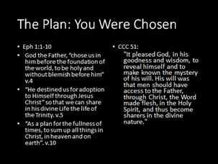 | B.The Plan: Eph 1:1-10  - CCC 51, “"It pleased God, in his goodness and wisdom, to reveal himself and to make known the mystery of his will. His will was that men should have access to the Father, through Christ, the Word made flesh, in the Holy Spirit, and thus become sharers in the divine nature."  2. “The sacraments are what God had in mind for you and me in the beginning when he made the heavens and the earth. The sacraments are what he brought about, little by little, all through the Old and New Testament....The sacraments have existed in God’s fatherly plan for us from all eternity. That plan continues in your life and mine. Salvation history hasn’t ended. It continues through the sacraments and through the covenant, in everything you do and pray, suffer and celebrate at home, at work, at leisure and at worship.”  -Scott Hahn  3. Consider the blueprint and details of the building of the Tabernacle and all of the furnishings that went into it (Ex 25). God comes across in the Old Testament as a meticulous designer. God is the author of everything. Every word, every chapter is filled with precision and purpose because our story is a part of His story.
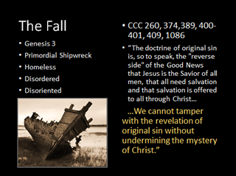 | B. The Fall CCC 1086, 389  1. Read Gen 3  2. Shipwrecked Homeless CCC 400-401, 409, 374-374, 260  - It was and continues to be an utter catastrophe both for humanity and for the whole material world. “The harmony in which they had found themselves, thanks to original justice, is now destroyed: the control of the soul's spiritual faculties over the body is shattered; the union of man and woman becomes subject to tensions, their relations henceforth marked by lust and domination. Harmony with creation is broken: visible creation has become alien and hostile to man. Because of man, creation is now subject "to its bondage to decay". Finally, the consequence explicitly foretold for this disobedience will come true: man will "return to the ground", for out of it he was taken. Death makes its entrance into human history” (CCC 400).  - “And my haunting instinct that somehow good was not merely a tool to be used, but a relic to be guarded, like the goods from Crusoe's ship—even that had been the wild whisper of something originally wise for, according to Christianity, we were indeed the survivors of a wreck the crew of a golden ship that had gone down before the beginning of the world.” GK Chesterton Orthodoxy, Ch 5  3. Disordered: The Hole CCC 377 unimpaired before the Fall ordered in his whole being…  a. “The first man was unimpaired and ordered in his whole being because he was free from the triple concupiscence that subjugates him to the pleasures of the senses, covetousness for earthly goods, and self-assertion, contrary to the dictates of reason.” CCC 377  4. Disordered: Molokai & the Sin Disease, “They don’t care how much you know until they know how much you care”.  - At first I was skeptical because of the nature and intensity of what our guys wrote. But when I shared it with my senior Christian Leadership class they began to recognize their own quotes and verified that they were real, authentic Damien issues. After my many Kairos experiences I shouldn’t have been surprised but I was. In response to the question, ‘What are your greatest struggles? Here are some of what our students at Damien wrote…  - ‘My brother passed away in Iraq and my parents divorced. No one knows I’m suicidal”  - “ I lost my uncle and grandpa within two years”  - “My mom had an abortion. My parents gave up on me”  - “My brother died when I was four”  - “I’ve thought about suicide and my father makes me feel worthless”  - “I have been saved from a suicide attempt but my best friend died in my arms’  - “My friend hung himself”  - “Depression, suicidal thoughts, lack of Faith”  - “My girlfriend was raped. I’ve considered suicide”  - “My parents got divorced because my dad was on drugs”  - “My dad made a new family and forgot about me and my sister”  - “I constantly fight with my mom”  - “ I don’t talk to my parents, my life is sad”  - “ My sister disowned my family”  - “My parents are divorced and I have FAKE relationship with my dad”  - “My mom was beaten by her boyfriend, and I was sent to juvie for defending her”  - ‘I never met my father”  - “I heard my dad say ‘he didn’t love me’ and I haven’t seen him for four years”  - “Family anger. Fighting with parents. Anger. Father left when I was young then came back when I was 13. I have a weight issue”  - “ I suffer from depression”  - “My mom is struggling with cancer”  - “I have a disabled sister”  - “I struggle everyday with OCD”  - “My sister can’t feel her lower extremities and my dad just had heart surgery”  - “Cystic Fibrosis”  - “ I have a poor self-image”  - “I’m starting to get scared to stand up for what I believe in”  - “ I want to be known as a better athlete”  - “I’m scared I will let everyone down and won’t be good enough for anyone”  - “Overcoming obesity”  - “I struggle with cutting and drug addiction”  - “My dad’s an alcoholic”  - “I was addicted to pornography”  - “My parents are constantly fighting. I think about all the names I’ve been called and I feel alone”  - “Teased at school everyday”  - “Being made fun of because of my weight”  - “I was abused when I was little”  5. Caution: Do not underestimate the fundamental importance of this event. The danger is to dismiss the story of Adam and Eve and the forbidden fruit as a child’s story, a fairy tale or a mere myth.  The religious truth of this story is carefully and emphatically stated with much clarity in the Catechism. While Genesis uses poetic and figurative language, it is made clear in the Catechism that the Church understands this as a real event that, in a mystery, unfolded in time.  “The account of the fall in Genesis 3 uses figurative language, but affirms a primeval event, a deed that took place at the beginning of the history of man. Revelation gives us the certainty of faith that the whole of human history is marked by the original fault freely committed by our first parents” (CCC 390).
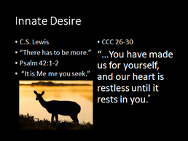 | C. Innate Desire  1. Innate Desire CCC 26-30 “The desire for God is written in the human heart, because man is created by God and for God; and God never ceases to draw man to himself. Only in God will he find the truth and happiness he never stops searching for: The dignity of man rests above all on the fact that he is called to communion with God. This invitation to converse with God is addressed to man as soon as he comes into being. For if man exists it is because God has created him through love, and through love continues to hold him in existence. He cannot live fully according to truth unless he freely acknowledges that love and entrusts himself to his creator” (CCC 27).  2. -CS Lewis “The Christian says, 'Creatures are not born with desires unless satisfaction for those desires exists. A baby feels hunger: well, there is such a thing as food. A duckling wants to swim: well, there is such a thing as water. Men feel sexual desire: well, there is such a thing as sex. If I find in myself a desire which no experience in this world can satisfy, the most probable explanation is that I was made for another world.”  3.-Fr. Thomas Dubay-”Mere animals do not and cannot have this inner aching need, for the simple reason that material things are satisfied with visible creation and their place in it. Because you and I have intellects and wills rooted in our profound spiritual core, nothing finite and limited does, or ever can, fill us. Deep in our humanness is an ache for fullness, for infinity. We are completely satisfied by no individual egoism, by no series of selfish pursuits: vanity, fame, money, lust, power, drugs. Always the sinner seeks more accolades, more money, more recognition, more lewd eroticism, more control of others, more drugs. Never is he satisfied, never really happy and fulfilled.”  4.Tom Brady- In 2009, after winning three Superbowls and after marrying a supermodel Giselle, millionaire quarterback Tom Brady sat down for an interview on 60 Minutes. He had the audacity to say, “There has to be more than this.” Gifted with intelligence, athleticism and good looks got him everything the world says will make us happy and yet he is unfulfilled…”Why do I have three Super Bowl rings, and still think there's something greater out there for me? I mean, maybe a lot of people would say, "Hey man, this is what is." I reached my goal, my dream, my life. Me, I think: God, it's gotta be more than this. I mean this can't be what it's all cracked up to be. I mean I've done it. I'm 27. And what else is there for me?”  5. YHWH- “It is me you seek!”
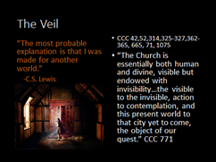 | C. The Veil: The Seen and The Unseen- CCC 1075, 325-327  Heaven and Earth- CCC 362-365  1.-Adam and Eve lost face to face relationship with God. The veil as barrier of sin.  a.-CCC. 314- Only at the end, when our partial knowledge ceases, when we see God "face to face", will we fully know the ways by which - even through the dramas of evil and sin - God has guided his creation to that definitive sabbath rest for which he created heaven and earth.  b.-Body and Soul- CCC 42 –The mystery of God…"the inexpressible, the incomprehensible, the invisible, the ungraspable"—‘God dwells in unapproachable Light’. 1 Tim 6:16  2.Fr. RAYMOND DE SOUZA, “Narnia lies just on the other side of the mysterious wardrobe. The Christian imagination is that the mystical and the supernatural lie just on the other side of the ordinary, the mundane, and the natural.”  3.Fr Andrew Greeley-“Catholics live in an enchanted world, a world of statues and holy water, stained glass and votive candles, saints and religious medals, rosary beads and holy pictures. But these Catholic paraphernalia are mere hints of a deeper and more pervasive religious sensibility which inclines Catholics to see the Holy lurking in creation. As Catholics, we find our houses and our world haunted by a sense that the objects, events, and persons of daily life are revelations of grace….”  4. In the sacraments we have the disguise of grace under signs and symbols. Water, wine, bread, oil, kneeling, standing, all serve as a veil that covers our encounter with Christ in the sacraments. We pass through the veil of the supernatural world most fully in the sacraments.  4.The other world is mentioned in the Creed. We give our assent to its existence every Sunday. God is the maker of heaven and earth of all that is seen and unseen, the visible and the invisible. The perception of separation of two realms or two worlds is blocked by the limit of our senses. Where our feeble senses fail faith must prevail. After all we are not materialists. There is more than matter. We are more than matter. We are partly invisible in that we have a soul, emotions, intellect, and will. We are the only creature hovering between the visible and invisible. The angels are pure spirit, the animals are animated by a lesser, natural soul that increases from a plant to an insect, to a rodent, to a gazelle, to a lion, to a dolphin, to an ape. You might rearrange that order but the point is that animals ascend toward man but fail to even be in his category. Just as we fail to be in the category of angels, which are pure spirit. We have an animal nature and an angelic nature. We have ordinary eyes and what we call ‘Eyes of Faith’.  - Faith makes us taste in advance the light of the beatific vision, the goal of our journey here below. Then we shall see God "face to face", "as he is". So faith is already the beginning of eternal life: When we contemplate the blessings of faith even now, as if gazing at a reflection in a mirror, it is as if we already possessed the wonderful things which our faith assures us we shall one day enjoy” (CCC 163).  - Faith is a light that enables us to see beyond the veil. “You have exactly the same eyes at night as you have in the day, but you cannot see at night, because you lack the additional light of the sun. So, too, let two minds with identically the same education, the same mental capacities, and the same judgment, look on a Host enthroned on an altar. The one sees bread, the other sees Christ, not, of course, with the eyes of the flesh, but with the eyes of faith. The reason for the difference is: one has a light which the other lacks, namely, the light of faith” (Archbishop Fulton J. Sheen).
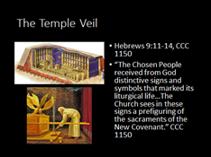 | The first clue to understanding why we can’t see the other world, the world of the supernatural is the Temple veil. Remember when Moses was asked to build the tabernacle, a dwelling place for God. He instructed him to separate the Holy room where the priests entered from the Holy of Holies where only the high priest could enter. This veil was a protective covering, not for God but for the people. The Shekinah glory of God hovered over the ark and it was powerful. The only thing that shielded the Levites from the flood of God’s holiness and the raging fire of his love was that little veil! The Scriptures teach us that they couldn’t handle penetrating into the supernatural presence of God.  Hebrews (:11-14) But when Christ came as high priest of the good things that are now already here, he went through the greater and more perfect tabernacle that is not made with human hands, that is to say, is not a part of this creation. He did not enter by means of the blood of goats and calves; but he entered the Most Holy Place once for all by his own blood, thus obtaining eternal redemption. The blood of goats and bulls and the ashes of a heifer sprinkled on those who are ceremonially unclean sanctify them so that they are outwardly clean. How much more, then, will the blood of Christ, who through the eternal Spirit offered himself unblemished to God, cleanse our consciences from acts that lead to death, so that we may serve the living God!
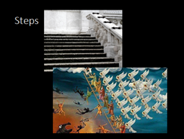 | - God continues to draw us to Himself-  a.CCC 55 "After the fall, [God] buoyed them up with the hope of salvation, by promising redemption; and he has never ceased to show his solicitude for the human race. For he wishes to give eternal life to all those who seek salvation by patience in well-doing." Even when he disobeyed you and lost your friendship you did not abandon him to the power of death. . . Again and again you offered a covenant to man.⁸  b.He declares in the Sermon on the Mount that they are blessed who hunger and thirst after holiness (Mt 5:6), and his Mother proclaims in her Magnificat that the Lord fills the hungry with every good thing (Lk 1:53). Jesus explicitly invites all those who are thirsty to come to him for a quenching with living water (Jn 7:37). At the very end of both Testaments this same invitation is extended to everyone: let all the thirsty come forward to be forever quenched with the life-giving waters, that is, an eternal enthrallment in Father, Son, and Holy Spirit seen face to face (Rev 22:17).  “I came that you may have life. And have it abundantly.”  - Jn 10:10  - We strive upward, ‘higher’ for God…  a.CCC 311- Angels and men, as intelligent and free creatures, have to journey toward their ultimate destinies by their free choice and preferential love.  b.Romano Guardini in Sacred Signs “Steps are an instance. Every one of the innumerable times we go upstairs a change, though too slight and subtle to be perceptible, takes place in us. There is something mysterious in  the act of ascending. Our intelligence would be puzzled to  explain it, but instinctively we feel that it is so. We are made that way.  When the feet mount the steps, the whole man, including his spiritual substance, goes up with them. All ascension, all going up, if we will but give it thought, is motion in the direction of that high place where everything is great, everything made perfect.  For this sense we have that heaven is "up" rather than "down" we depend on something in us deeper than our reasoning powers. How can God be up or down? The only approach to God is by becoming better morally, and what has spiritual improvement to do with a material action like going up a pair of stairs? What has pure being to do with a rise in the position of our bodies? There is no explanation. Yet the natural figure of speech for what is morally bad is baseness, and a good and noble action we call a  high action. In our minds we make a connection, unintelligible but real, between rising up and the spiritual approach to God; and Him we call the All-Highest.  So the steps that lead from the street to the church remind us that in going up into the house of prayer we are coming nearer to God; the steps from the nave to the choir, that we are entering in before the All-Holy. The steps between the choir and the altar say to whoever ascends them the same words that God spoke to  Moses on Mount Horeb: "Put your shoes from off your feet, for the place whereon thou standest is holy ground." The altar is the threshold of eternity.”  c.Creed-’Higher’ “When dreaming I'm guided to another world. Time and time again. At sunrise I fight to stay asleep'. Cause I don't want to leave the comfort of this place'. Cause there's a hunger, a longing to escape from the life I live when I'm awake. So let's go there. Let's make our escape. Come on, let's go there. Let's ask can we stay? Can you take me higher? To the place where blind men see. Can you take me higher? To the place with golden streets. Although I would like our world to change. It helps me to appreciate. Those nights and those dreams. But, my friend, I'd sacrifice all those nights. If I could make the Earth and my dreams the same. The only difference is to let love replace all our hate. So let's go there. Let's make our escape. Come on, let's go there. Let's ask can we stay?”
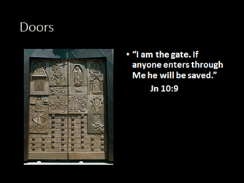 | 1.Guardini-“Between the outer and the inner world are the doors. They are the barriers between the market place and the sanctuary, between what belongs to the world at large and what has become consecrated to God. And the door warns the man who opens it to go inside that he must now leave behind the thoughts, wishes and cares which here are out of place, his curiosity, his vanity, his worldly interests, his secular self. "Make yourself clean. The ground you tread is holy ground."...”
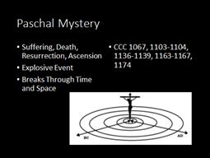 | D. Paschal Mystery  - CCC 1067... "The wonderful works of God among the people of the Old Testament were but a prelude to the work of Christ the Lord in redeeming mankind and giving perfect glory to God. He accomplished this work principally by the Paschal mystery of his blessed Passion, Resurrection from the dead, and glorious Ascension, whereby 'dying he destroyed our death, rising he restored our life.' For it was from the side of Christ as he slept the sleep of death upon the cross that there came forth 'the wondrous sacrament of the whole Church. For this reason, the Church celebrates in the liturgy above all the Paschal mystery by which Christ accomplished the work of our salvation.”  - Broke Time Barrier: Like Atomic Bomb of Light and Love-CCC 1165 When the Church celebrates the mystery of Christ(The PM), there is a word that marks her prayer: "Today!" - a word echoing the prayer her Lord taught her and the call of the Holy Spirit. This "today" of the living God which man is called to enter is "the hour" of Jesus' Passover, which reaches across and underlies all history: Life extends over all beings and fills them with unlimited light; the Orient of orients pervades the universe, and he who was "before the daystar" and before the heavenly bodies, immortal and vast, the great Christ, shines over all beings more brightly than the sun. Therefore a day of long, eternal light is ushered in for us who believe in him, a day which is never blotted out: the mystical Passover.  - Albert Einstein was the only person to ever get close to unraveling the mystery of time travel. There is a true story that Fr. Benedict Groeschel used to tell regarding a priest who visited Einstein one afternoon. “Father Charlie had come to talk about Christ in light of Einstein's theories and Einstein obliged and directed the discussion towards the Mass. "What is it? What happens?" Einstein asked his guest. Father Charlie explained that during Mass heaven and earth are joined by the infinite living body of Christ when the whole substance of bread and wine becomes the true body and blood of Christ, only the appearances of the bread and wine remaining. Einstein became extremely interested in the concept of transubstantiation, the changing of one substance into another. He asked Father Charlie to explain the conversion in the Eucharist, by the priest at Mass. Father Charlie eagerly explained transubstantiation to his host as analogous to Einstein's famous formula E=MC²: Just as matter can be broken into energy—God becomes present on earth in the Mass. While Einstein listened attentively, Father Charlie said, "During the Last Supper Christ said to his disciples, 'This is my body, this is my blood, that is being shed for you.' This means that what looks like bread and wine by God's power have become the body and blood of Christ." "Then this means," Einstein said, "that Christ is infinite and timeless”
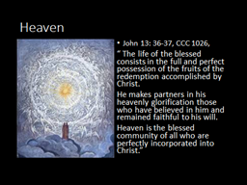 | E. Heaven CCC 1090, 1130  1. So what can we know about heaven? We know that we will be blown away with unexpected wonder. “Eye has not seen, nor ear heard, Nor have entered into the heart of man the things which God has prepared for those who love Him” (1 Cor 2:9).  - Here is what we talk about…  - People who believe in Life after death take life more seriously. “I am more than my body. I am a person with a unique soul.”  - Christ taught in heaven and hell. Reward and Treasure—Two words Jesus uses.  - God is all loving and all-powerful. He wants us there.  - Hope for heaven is a natural desire.  - Long range justice: Rewards and punishment that don't take place on earth.  - Testimony of Saints, Seers, Mystics and patients that have been resuscitated from 'near death'.  - The Resurrection of Jesus.  - Not a physical place (yet) but a living, personal relationship with God.  - Fullness of communion with God.  - More alive than now—a type of birth  - With God-Full immersion into life of trinity  - With Angels, Virgin Mary, Saints, saints, communal.  - The completion of unfinished love of others on earth, including eros.  - State of supreme happiness.  - Begins on earth with Baptism as the insertion into Paschal Mystery, Human love, Eucharist are foretaste.  3.Dante- “O everlasting Light, you dwell alone  In yourself, know yourself alone, and known  And knowing, love and smile upon yourself!  That middle circle which appeared in you  To be conceived as a reflected light,  After my eyes had studied it a while,  Within itself and in its coloring  Seemed to be painted with our human likeness  So that my eyes were wholly focused on it.  As the geometer who sets himself  To square the circle and who cannot find,  For all his thought, the principle he needs,  Just so was I on seeing this new vision  I wanted to see how our image fuses  Into the circle and finds its place in it,  Yet my wings were not meant for such a flight —  Except that then my mind was struck by lightning  Through which my longing was at last fulfilled.  Here powers failed my high imagination:  But by now my desire and will were turned,  Like a balanced wheel rotated evenly,  By the Love that moves the sun and the other stars.-Dante-Paradisio
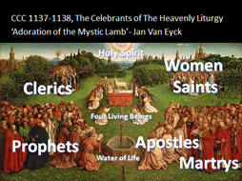 | 4. Celebrants of the Heavenly Liturgy CCC 1137-1138  ‘The book of Revelation of St. John, read in the Church's liturgy, first reveals to us, "A throne stood in heaven, with one seated on the throne": "the Lord God." It then shows the Lamb, "standing, as though it had been slain": Christ crucified and risen, the one high priest of the true sanctuary, the same one "who offers and is offered, who gives and is given." Finally it presents "the river of the water of life . . . flowing from the throne of God and of the Lamb," one of most beautiful symbols of the Holy Spirit. Recapitulated in Christ," these are the ones who take part in the service of the praise of God and the fulfillment of his plan: the heavenly powers, all creation (the four living beings), the servants of the Old and New Covenants (the twenty-four elders), the new People of God (the one hundred and forty-four thousand), especially the martyrs "slain for the word of God," and the all-holy Mother of God (the Woman), the Bride of the Lamb, and finally "a great multitude which no one could number, from every nation, from all tribes, and peoples and tongues."
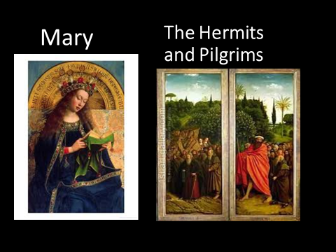 | Pope John Paul II in an address in St. Peter's square on Sunday Feb. 12, 1984 said: "Today I wish to dwell with you on the Blessed Virgin's presence in the celebration of the Liturgy.... Every liturgical action ... is an occasion of communion ... and in a particular way with Mary.... Because the Liturgy is the action of Christ and of the Church ... [and] she is inseparable from one and the other.... Mary is present in the memorial--the liturgical action--because she was present at the saving event.... She is at every altar where the memorial of the passion and Resurrection is celebrated, because she was present, faithful with her whole being to the Father's plan, at the historic salvific occasion of Christ's death."
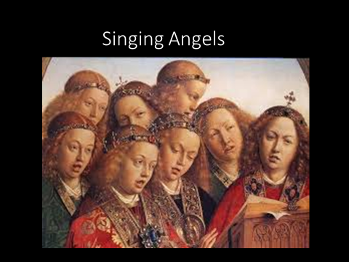 | "In the earthly liturgy we share in a foretaste of that heavenly liturgy which is celebrated in the Holy City of Jerusalem toward which we journey as pilgrims, where Christ is sitting at the right hand of God, Minister of the sanctuary and of the true tabernacle. With all the warriors of the heavenly army we sing a hymn of glory to the Lord; venerating the memory of the saints, we hope for some part and fellowship with them; we eagerly await the Savior, our Lord Jesus Christ, until he, our life, shall appear and we too will appear with him in glory.“ CCC 1090
Catholic Liturgy  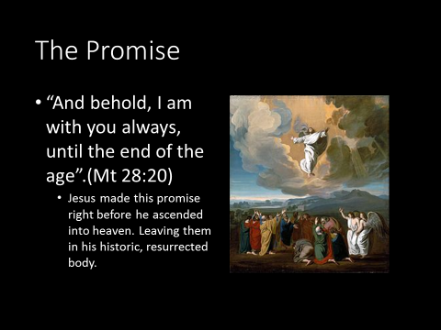  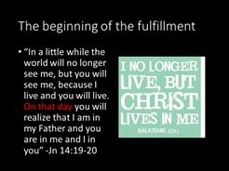 | CCC 788-When his visible presence was taken from them, Jesus did not leave his disciples orphans. He promised to remain with them until the end of time; he sent them his Spirit.²¹⁸ As a result communion with Jesus has become, in a way, more intense: "By communicating his Spirit, Christ mystically constitutes as his body those brothers of his who are called together from every nation."  CCC 790…"In that body the life of Christ is communicated to those who believe, and who, through the sacraments, are united in a hidden and real way to Christ in his Passion and glorification."
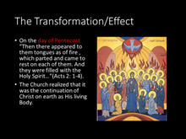 | CCC 1119- Forming "as it were, one mystical person" with Christ the head, the Church acts in the sacraments as "an organically structured priestly community."³⁶ Through Baptism and Confirmation the priestly people is enabled to celebrate the liturgy, while those of the faithful "who have received Holy Orders, are appointed to nourish the Church with the word and grace of God in the name of Christ."
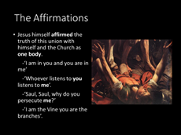 | CCC 787-789-“From the beginning, Jesus associated his disciples with his own life…Jesus spoke of a still more intimate communion between him and those who would follow him: "Abide in me, and I in you. . . . I am the vine, you are the branches. And he proclaimed a mysterious and real communion between his own body and ours: "He who eats my flesh and drinks my blood abides in me, and I in him…Not only is she gathered around him; she is united in him, in his body. ”
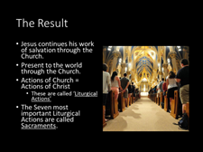 | CCC 797-"What the soul is to the human body, the Holy Spirit is to the Body of Christ, which is the Church."²⁴³ "To this Spirit of Christ, as an invisible principle, is to be ascribed the fact that all the parts of the body are joined one with the other and with their exalted head; for the whole Spirit of Christ is in the head, the whole Spirit is in the body, and the whole Spirit is in each of the members."²⁴⁴ The Holy Spirit makes the Church "the temple of the living God"
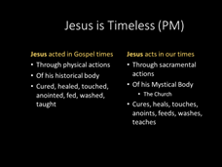 | CCC 1116- Sacraments are "powers that comes forth" from the Body of Christ, which is ever-living and life-giving. They are actions of the Holy Spirit at work in his Body, the Church. They are "the masterworks of God" in the new and everlasting covenant.
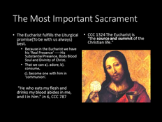 | CCC 1088- "To accomplish so great a work" - the dispensation or communication of his work of salvation - "Christ is always present in his Church, especially in her liturgical celebrations. He is present in the Sacrifice of the Mass not only in the person of his minister, 'the same now offering, through the ministry of priests, who formerly offered himself on the cross,' but especially in the Eucharistic species. By his power he is present in the sacraments so that when anybody baptizes, it is really Christ himself who baptizes. He is present in his word since it is he himself who speaks when the holy Scriptures are read in the Church. Lastly, he is present when the Church prays and sings, for he has promised 'where two or three are gathered together in my name there am I in the midst of them."'
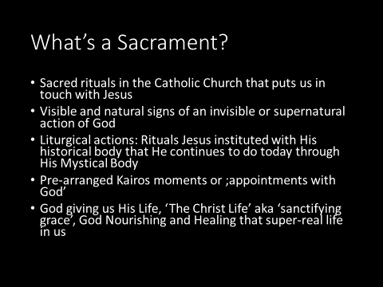 | Official definition: CCC1131- "the sacraments are efficacious signs of grace, instituted by Christ and entrusted to the Church, by which divine life is dispensed to us. The visible rites by which the sacraments are celebrated signify and make present the graces proper to each sacrament.”  CCC 1123-"The purpose of the sacraments is to sanctify men, to build up the Body of Christ and, finally, to give worship to God. Because they are signs they also instruct. They not only presuppose faith, but by words and objects they also nourish, strengthen, and express it. That is why they are called 'sacraments of faith.; “
Sacraments Categories
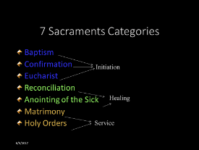

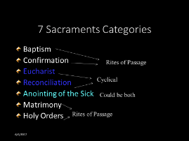

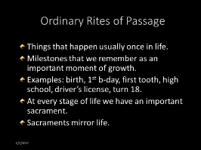

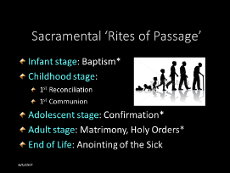

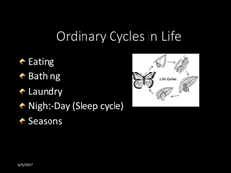

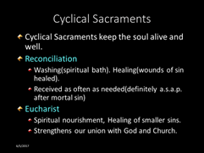

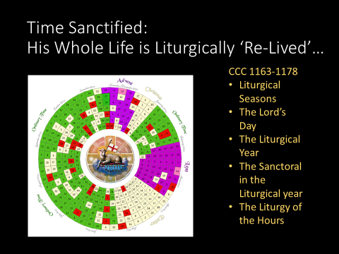 | Incarnational Principle- Because God entered time, time can become holy.  Christians understand time in a different way than other people. Because of the Liturgical Year. We are drawn into a cycle that can become such a part of our live that it determines how we understand the structure of each passing year.  All of the great moments of the Liturgical year look back to the salvific events of Jesus Christ, the Lord of History. Those events are made present here and now as moments of grace.  It carries us along. It sets up a series of appointments with the Lord. Within this ‘framework of obligation, duty, and covenant, we are a part of something bigger than ourselves.
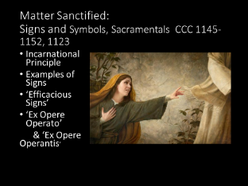 | The Incarnational Principle: Because God become matter, matter can be holy…  Biblical:  a. “A woman who had had a hemorrhage for twelve years, and had endured much at the hands of many physicians, and had spent all that she had and was not helped at all, but rather had grown worse— after hearing about Jesus, she came up in the crowd behind Him and touched His cloak. For she thought, ‘If I just touch His garments, I will get well.’ Immediately the flow of her blood was dried up; and she felt in her body that she was healed of her affliction. Immediately Jesus, perceiving in Himself that the power proceeding from Him had gone forth, turned around in the crowd and said, ‘Who touched My garments?’ And His disciples said to Him, ‘You see the crowd pressing in on You, and You say, ‘Who touched Me?’ And He looked around to see the woman who had done this. But the woman fearing and trembling, aware of what had happened to her, came and fell down before Him and told Him the whole truth. And He said to her, ‘Daughter, your faith has made you well; go in peace and be healed of your affliction’ “ (Mk 5:25-34).  b. In this story the woman touched Jesus cloak and power left Him, went through the cloak and into her. Later, Paul’s handkerchief was a conduit of God’s healing grace…  “God was performing extraordinary miracles by the hands of Paul, so that handkerchiefs or aprons were even carried from his body to the sick, and the diseases left them and the evil spirits went out” (Acts 19:11-12).  Sacramentals CCC 1670: “Sacramentals do not confer the grace of the Holy Spirit in the way that the sacraments do, but by the Church's prayer, they prepare us to receive grace and dispose us to cooperate with it. "For well-disposed members of the faithful, the liturgy of the sacraments and sacramentals sanctifies almost every event of their lives with the divine grace which flows from the Paschal mystery of the Passion, Death, and Resurrection of Christ. From this source all sacraments and sacramentals draw their power. There is scarcely any proper use of material things which cannot be thus directed toward the sanctification of men and the praise of God."  Sacramentals: As we can see, the incarnational principle is a biblical principle. Based on it, the Church has a blessing for everything, the objects and vestments used in the Mass and other sacraments, whole churches, cars, roads, cities, football fields, houses, medals, prayer cards, crucifixes, salt, oil, water, bread, wine, bibles, scapulars, rosaries etc..  - The Beer Blessing, From the Rituale Romanum no 58, “Bless, O Lord, this creature beer, that Thou hast been pleased to bring forth from the sweetness of the grain: that it might be a salutary remedy for the human race: and grant by the invocation of Thy holy name, that, whosoever drinks of it may obtain health of body and a sure safeguard for the soul. Through Christ our Lord. Amen.”  - Signs and Symbols CCC 1145-1152, 1123  - The biggest misconception about the sacraments is that they are merely symbolic representations of God’s presence. The sacraments are real and powerful. The sacraments are a matter of eternal life and eternal death. This is why the vocabulary about sacraments matters. Great Catholic American authors Flannery O’Connor…“Well, toward morning the conversation turned on the Eucharist, which I, being the Catholic, was obviously supposed to defend. Mrs. Broadwater said when she was a child and received the Host, she thought of it as the Holy Ghost, He being the ‘most portable’ person of the Trinity; now she thought of it as a symbol and implied that it was a pretty good one. I then said, in a very shaky voice, ‘Well, if it's a symbol, to hell with it.’ That was all the defense I was capable of but I realize now that this is all I will ever be able to say about it, outside of a story, except that it is the center of existence for me; all the rest of life is expendable.” -Flannery O’Connor  What O’Connor was saying is that symbols are always duds. They can only remind the brain about a past encounter with some reality. Signs, on the other hand, are indicators of a present reality. An example of the most common symbol of love is a heart. However, a sign of love is a kiss. Signs are connected to the present and they signify something not just symbolize something that has been or something abstract. Signs are more active, and more personal; symbols are more inert, and more universal.  Examples of Signs/Symbols: Clouds-rain, Smoke-fire  The words symbol and sign both have a place when discussing sacraments. If there was no spiritual effect, if sacraments were not efficacious then the word symbol would be sufficient. But since sacraments bring about a spiritual change and not just remind us of the idea then they must be called signs. A sign can indicate the unseen change that the sacrament brings about. We go so far as to say ‘the sign becomes what it signifies’ through the power of the Holy Spirit. They connect us to the reality of the transformative encounter with Christ. For example bread and wine become what they signify-the ‘real presence’ of Jesus’ body and blood. It is Christ who acts in the sacraments and communicates the grace they signify.  This is why the CCC uses the words sign and signify in relation to sacraments not symbol and symbolize… “The sacraments are efficacious signs of grace, instituted by Christ and entrusted to the Church, by which divine life is dispensed to us. The visible rites by which the sacraments are celebrated signify and make present the graces proper to each sacrament. They bear fruit in those who receive them with the required dispositions.” CCC 1131  d. Ex opere Operato-Efficacious- 1127-1128 “ This is the meaning of the Church's affirmation that the sacraments act ex opere operato (literally: "by the very fact of the action's being performed"), i.e., by virtue of the saving work of Christ, accomplished once for all. It follows that "the sacrament is not wrought by the righteousness of either the celebrant or the recipient, but by the power of God."  From the moment that a sacrament is celebrated in accordance with the intention of the Church, the power of Christ and his Spirit acts in and through it, independently of the personal holiness of the minister. Nevertheless, the fruits of the sacraments also depend on the disposition of the one who receives them.”-CCC 1128
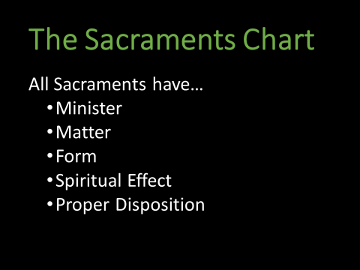 | - Look at Sacraments Chart …  Minister CCC 1548 In the ecclesial service of the ordained minister, it is Christ himself who is present to his Church as Head of his Body, Shepherd of his flock, high priest of the redemptive sacrifice, Teacher of Truth. This is what the Church means by saying that the priest, by virtue of the sacrament of Holy Orders, acts in persona Christi ..It is the same priest, Christ Jesus, whose sacred person his minister truly represents. Now the minister, by reason of the sacerdotal consecration which he has received, is truly made like to the high priest and possesses the authority to act in the power and place of the person of Christ himself.  Matter and Form Every sacrament has form and matter. Form is the necessary words spoken by the minister. Matter is the necessary material thing such as oil or water or it is the ritual action such as laying on of hands or anointing or it is the words of the recipient such as the confession of sins in Reconciliation. Usually the form and matter happen concurrently such as the pouring of water and the words, ‘I baptize you in the name of the Father, the Son and the Holy Spirit’ in Baptism. Though there are many other words and other signs and symbols these are identifiable words and actions that are essential to the validity of the sacrament.  Effect CCC 1129-The Church affirms that for believers the sacraments of the New Covenant are necessary for salvation.⁵¹ "Sacramental grace" is the grace of the Holy Spirit, given by Christ and proper to each sacrament. The Spirit heals and transforms those who receive him by conforming them to the Son of God. The fruit of the sacramental life is that the Spirit of adoption makes the faithful partakers in the divine nature⁵² by uniting them in a living union with the only Son, the Savior.  -----Felt? CCC 1157-Moved to tears  Disposition  Baptism, state of grace, faith and openness- There must be, at least in the case of an adult, an openness to use the sufficient grace which is available in a sacrament. ... The principle of ex opere operato affirms that while a proper disposition (openness) is necessary to receive the efficacious grace in the sacraments, it is not the cause of the sufficient grace.

Appendix
______________________________________________

Bishop’s Framework: Intro to Sacraments and Sacraments of Initiation.
I. The Sacramental Nature of the Church
A. Definition of sacrament. 1. A sacrament is an efficacious sign of grace, instituted by Christ and entrusted to the Church, by which divine life of grace is dispensed to us through the work of the Holy Spirit (CCC, no. 1131). 2. Eastern Churches use the word “mystery” for sacrament and celebrate them in a similar but not essentially different way. 3. Sacraments confer the grace they signify (CCC, no. 1127).a. Grace: sanctifying and actual—gratuitous (CCC, nos. 1996-2005). b. Sacramental grace (CCC, no. 1129).
B. The Church and the sacramental economy of salvation (CCC, no. 849). 1. Jesus Christ is the living, ever-present sacrament of God (CCC, nos. 1088-1090). 2. The Church as universal sacrament of Jesus Christ (CCC, nos. 774-776). a. The Church is the sacrament of salvation, the sign and the instrument of the communion of God and all (CCC, no. 780). b. The Church has a sacramental view of all reality (CCC, no. 739).c. The Church is the sacrament of the Trinity’s communion with us (CCC, no. 774). C. Redemption is mediated through the seven sacraments. 1. Christ acts through the sacraments (CCC, nos. 1084-1085). a. Signs and symbols (CCC, nos. 1145-1152). b. Sacraments for healing and sanctification (CCC, nos. 1123, 1421). c. Experiential sign of Christ’s presence (CCC, nos. 1115-1116). 2. The Church at prayer (CCC, no. 1073). a. Prayer defined; different forms (CCC, nos. 2559, 2565). b. Essential for a believer (CCC, no. 2558). c. Liturgical prayer and the sacraments (CCC, nos. 1137-1144). d. Personal prayer; Christian meditation (CCC, nos. 2626-2643, 2705-2719).
II. The Sacraments of Initiation (CCC, no. 1212)
A. Baptism: the sacrament which is the birth of the baptized into new life in Christ. In Baptism, Original Sin is forgiven along with all personal sins. By it we become adoptive children of the Father, members of Christ, and temples of the Holy Spirit; it also incorporates us into the Church and makes us sharers in the priesthood of Christ (CCC, nos. 1279-1280). 1. Understanding the sacrament. a. Scriptural basis. 1) The Sacrament of Baptism is pre-figured in the Old Testament at creation when the Spirit of God hovered over the waters at creation (Gn 1–2); in Noah’s ark (Gn 7); in the crossing of the Red Sea (Ex 14) and the Jordan (CCC, nos. 1217-1222). 2) New Testament references: Mt 3:1-12; Mt 3:13-17; Mt 29:19; Mk 1:9-11; Lk 3:21-22; Jn 1:22-34; Jn 3:1-15; Acts 2:37-41 (CCC, nos. 1223-1225). b. Historical development (CCC, nos. 1229- 1233). 1) Baptism of blood (CCC, no. 1258). 2) Baptism of desire (CCC, nos. 1258-1261). c. Theology (CCC, nos. 1217-1228). 2. Celebration (CCC, nos. 1229-1245). a. Baptism of adults (CCC, nos. 1247-1249). b. Baptism of infants (CCC, nos. 403, 1231, 1233, 1250-1252, 1282, 1290).1) The question of infants who die before Baptism (CCC, no. 1283). c. Role of godparents (CCC, no. 1255). 3.Matter and Form: Essential elements (CCC, nos. 1239-1240).a. Immersion or the triple pouring of water on the head (CCC, nos. 694, 1214, 1217, 1240). b. Saying the words of the formula (CCC, no. 1240). 4. Other elements: (CCC, nos. 1237-1245). 5. Spiritual effect: Effects of the sacrament (CCC, nos. 1262-1270). a. Die and rise with Christ (CCC, no. 1227). b. Freed from Original Sin and all sins (CCC, no. 1263). c. Adopted children of God (CCC, nos. 1265-1266). d. Members of the Church (CCC, nos. 1267-1270). e. Indelible character; this sacrament cannot be repeated (CCC, nos. 1272-1274). f. Holy Spirit and discipleship (CCC, no. 1241). 6. Disposition-Requirements for reception. a. For adults (CCC, nos. 1247-1249). b. For infants (CCC, nos. 1250-1252). c. Catechesis for baptized (CCC, nos. 1253- 1255). 7. Minister of the sacrament (CCC, no. 1256). a. Ordinary circumstances. b. In danger of death. Other: 8. Necessity of Baptism (CCC, nos. 1257-1261). 9. Implications. a. Members of Church (CCC, no. 1267). b. Common priesthood (CCC, no. 1268). c. Rights and duties (CCC, no. 1269). d. Call to mission (CCC, no. 1270). e. Ecumenical aspect (CCC, no. 1271). 10. Appropriating and living this sacrament (CCC, no. 1694). a. Reminders of our Baptism. 1) In the Church’s liturgy: Easter vigil, renewal of baptismal promises, sprinkling rite at Mass (CCC, nos. 281, 1217, 1254, 1668, 2719). 2) In pious practices: blessing with holy water (fonts in churches and homes), sign of the cross (CCC, no. 1668). b. Prayer and reflection on the meaning of Baptism (CCC, nos. 1694, 1811, 1966, 1988, 1987, 1992, 1997, 2015). 1) Sharing in the Death and Resurrection of Christ. 2) Turning away from sin and selfish actions; ongoing conversion.
B. Confirmation: the sacrament in which the gift of the Holy Spirit received at Baptism is confirmed, strengthened, and perfected for living the Christian life and spreading the faith to others; in this sacrament we receive a permanent sign or character so it cannot be repeated. 1. Understanding the sacrament. a. Scriptural basis. 1) The book of Isaiah foretold that the Spirit of the Lord shall rest on the hoped-for Messiah (Is 11:2; CCC, no. 1286). 2) The Holy Spirit descended on the Church (Acts 8:14-17; CCC, nos. 1287-1288). b. Historical development (CCC, nos. 1290-1292). c. Theology. 1) Western Church (CCC, nos. 1286-1288). 2) Eastern Churches (CCC, no. 1289). 2. Celebration. a. Rite of Confirmation (CCC, nos. 1298-1300). b. Rite of Christian Initiation of Adults (RCIA) (CCC, nos. 1232-1233, 1298). c. Eastern Catholic Churches confirm (chrismate) at the time of Baptism and, in some cases, administer Eucharist then as well (CCC, nos. 1290-1292). 3. Matter and Form-Essential elements of the sacrament (CCC, no. 1300). a. Laying-on of hands and anointing with chrism. b. Saying the words of the formula. 4. Disposition-Requirements for reception. a. Baptized and age (CCC, nos. 1306-1308). b. Preparation, Confession, sponsor (CCC, nos. 1309-1310). 5. Minister (CCC, nos. 1312-1314). 6. Spiritual Effect: Effects and implications (CCC, no. 1303). a. Perfection of baptismal grace (CCC, no. 1285). b. Help of Holy Spirit’s gifts and fruits (CCC, nos. 1830-1832). c. Indelible character; this sacrament cannot be repeated (CCC, nos. 1303-1305). d. Call to spread and defend faith (CCC, no. 1303). e. Discernment of God’s call (CCC, no. 1303). f. Stewardship (CCC, no. 1303). Other: 7. Appropriating and living this sacrament: life in the Holy Spirit (CCC, no. 1694). a. How to know the Holy Spirit’s promptings and actions in your life, with the help of the Holy Spirit (CCC, no. 1694). 1) Learn Sacred Scripture (CCC, nos. 50-51, 94-95, 1066). 2) Live the sacraments (CCC, nos. 1071-1072, 1091-1092). 3) Love the Catholic Church—the Church that Christ began. b. Prayer is the foundation for knowing and following the will and actions of the Holy Spirit (CCC, nos. 1309, 1073, 2670-2672).
C. Holy Eucharist: the sacrament which re-presents in the Mass the sacrificial Death of Christ and his Resurrection—making it possible for us to eat his Body and drink his Blood (CCC, no. 1323). 1. Understanding the sacrament. a. Scriptural basis: Ex 12; Mt 14:13-21; Mt 26: 26-29; Mk 6:30-33; Mk 14:22-25; Lk 9:10-17; Lk 22:14-20; Jn 2:1-12; Jn 6:22-59; Jn 13–17; 1 Cor 11:23ff. (CCC, nos. 1337-1344). 1) The Eucharist is pre-figured in the Old Testament, beginning with the priest-king Melchizedek (Gn 14:18-20), Israel eating unleavened bread every year at Passover, and Yahweh providing manna from heaven (CCC, nos. 1333, 1544). b. Historical development (CCC, nos. 1324- 1332, 1345). c. Theology. 1) Signs (CCC, nos. 1333-1336). 2) Institution (CCC, nos. 1337-1340). 3) “In memory” (CCC, nos. 1341-1343). 4) Thanksgiving and praise (CCC, nos. 1359-1361). 5) Sacrificial memorial (CCC, nos. 1362-1372). 6) Ecclesia de Eucharistia. 2. Celebration. a. Parts of the Mass (CCC, nos. 1348-1355). b. Minister Roles of priests and deacons (CCC, nos. 1566, 1570). c. Roles of faith community (CCC, nos. 1140, 1348). 3. Matter and Form: Essential elements. a. Bread (unleavened in Latin Church, leavened in Eastern Churches) and wine from grapes (CCC, no. 1412; CIC, cc. 924 §§1-3, 926, 927). b. Eucharistic Prayer (CCC, nos. 1352-1355). 4. Christ’s Real Presence. a. Transubstantiation (CCC, nos. 1373-1377). b. Worship of the Eucharist. 1) Adoration (CCC, no. 1378). 2) Tabernacle (CCC, no. 1379). 3) Reverence (CCC, nos. 1385-1386, 1418). 5. Spiritual Effect Effects of the sacrament. a. Union with Jesus and Church (CCC, nos. 1391, 1396). b. Forgiveness of venial sin (CCC, no. 1394). c. Protection from grave sin (CCC, no. 1395). d. Commits us to the poor (CCC, no. 1397). 6. Requirements for fruitful reception. a. Baptized member of the Church who believes in the Real Presence and Transubstantiation (CCC, nos. 1376, 1385, 1387-1388). b. Free from grave sin (CCC, no. 1385). c. One hour fast from food and drink (CCC, no. 1387). 7. Other receptions. a. Frequent Communion (CCC, nos. 1388- 1389). b. Viaticum (CCC, nos. 1524-1525). c. Eucharist two times a day (CIC, c. 917). 8. Minister of the sacrament (CCC, nos. 1369, 1566). 9. Role of extraordinary ministers of Holy Communion (CCC, no. 1411; CIC, c. 910 §2, c. 230 §3). 10. Implications. a. Ecumenical (CCC, no. 1398). b. Love of God, neighbor, and poor (CCC, nos. 1396-1397). c. Nourishing Christ’s life in us (CCC, no. 1392). 11. Appropriating and living this sacrament. a. Active participation in Mass where the Lord comes in both word and sacrament (CCC, nos. 2042, 2181-2182). b. Prayer of thanksgiving on receiving Jesus Christ in the Eucharist (CCC, nos. 1358- 1359). c. Reflective prayer on the meaning of Christ’s Death and Resurrection, and petition for the grace to give to others of ourselves as the Lord did (CCC, nos. 1359-1361).

