Name and Period:
CREED – Higher | 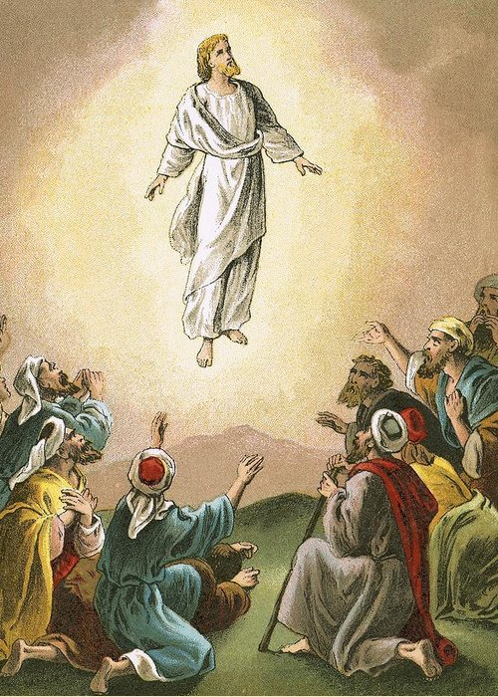
When dreaming I'm guided to another world  Time and time again  At sunrise I fight to stay asleep  'Cause I don't want to leave the comfort of this place  'Cause there's a hunger, a longing to escape  From the life I live when I'm awake  So let's go there  Let's make our escape  Come on, let's go there  Let's ask can we stay?  Can you take me higher?  To the place where blind men see  Can you take me higher?  To the place with golden streets  Although I would like our world to change  It helps me to appreciate  Those nights and those dreams  But, my friend, I'd sacrifice all those nights  If I could make the Earth and my dreams the same  The only difference is  To let love replace all our hate  So let's go there  Let's make our escape  Come on, let's go there  Let's ask can we stay? | - Underline all of the phrases in the lyrics that refer to the concept of Innate Desire.  - Circle all of the phrases in the lyrics that refer to the concept of Escapism.  - Create a box around any phrases that refer to Heaven.  - What are three phrases that are biblical (referring to something in Scripture)?  - Is this song about the hope for heaven or the despair of being in a fallen world? Explain.  - Why does the song express a desire to go upward or ascend?  - In what way doe this song relate to the Twighlight Zone episode, ‘Five Characters in Search of an Exit”?  - What is the highest ideal or the goal of the person singing this song?

