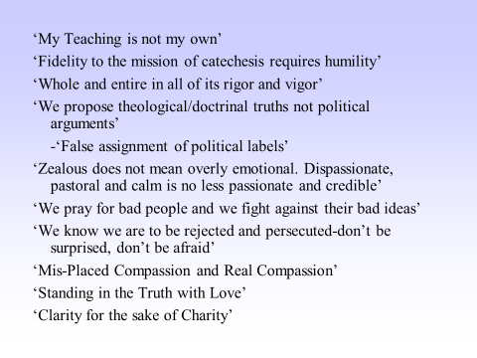 | CT 5: The definitive aim of catechesis is to put people not only in touch but in communion, in intimacy, with Jesus Christ: only He can lead us to the love of the Father in the Spirit and make us share in the life of the Holy Trinity.  CT 6: Christocentricity in catechesis also means the intention to transmit not one's own teaching or that of some other master, but the teaching of Jesus Christ, the Truth that He communicates or, to put it more precisely, the Truth that He is.  We must therefore say that in catechesis it is Christ, the Incarnate Word and Son of God, who is taught - everything else is taught with reference to Him - and it is Christ alone who teaches - anyone else teaches to the extent that he is Christ's spokesman, enabling Christ to teach with his lips.  Whatever be the level of his responsibility in the Church, every catechist must constantly endeavor to transmit by his teaching and behavior the teaching and life of Jesus. He will not seek to keep directed towards himself and his personal opinions and attitudes the attention and the consent of the mind and heart of the person he is catechizing.  Above all, he will not try to inculcate his personal opinions and options as if they expressed Christ's teaching and the lessons of His life. Every catechist should be able to apply to himself the mysterious words of Jesus: "My teaching is not mine, but his who sent me." St. Paul did this when he was dealing with a question of prime importance: "I received from the Lord what I also delivered to you."…what detachment from self must a catechist have in order that he can say: "My teaching is not mine!"  CT 30- In order that the sacrificial offering of his or her faith[75] should be perfect, the person who becomes a disciple of Christ has the right to receive " the word of faith"[76] not in mutilated, falsified or diminished form but whole and entire, in all its rigour and vigor. Unfaithfulness on some point to the integrity of the message means a dangerous weakening of catechesis and putting at risk the results that Christ and the ecclesial community have a right to expect from it.
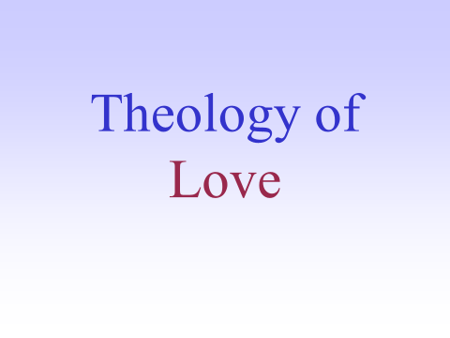 | “To defraud oneself of love is the most terrible, is an eternal loss, for  which there is no compensation, either in time or in eternity” -Kierkegaard  With these words, the philosopher Sören Kierkegaard  spoke of the worst deception that can happen in life: “to  defraud oneself of love.” This temptation is very strong today. In fact, we can ask two questions: Is it possible to believe in love?  Can we discover in love a path that, if followed, leads to  happiness? We are in the middle of a crisis that affects the credibility of love.  To our culture, love certainly seems funny, interesting, necessary—But not worthy of trust. It does not seem to be solid enough that  one can build one’s entire life on it.  (We are young, Heartache to heartache. We stand. No promises. No demands. Love is a battlefield. We are strong. No one can tell us we're wrong. Searching our hearts for so long. Both of us knowing Love is a battlefield”-Pat Benetar  These questions are  very important for Christian catechesis, because its task is precisely to avoid this deception. It teaches how to  “believe in love” (see 1 Jn 4:16), the love with which God  loved us first, brought us into existence, and called us to  build a fruitful life. … http://www.usccb.org/beliefs-and-teachings/how-we-teach/catechesis/catechetical-sunday/marriage/upload/teaching-aids-granados.pdf
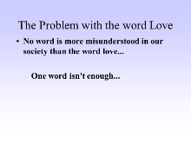
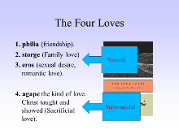 | In order for catechesis to introduce us into the mystery of God’s love, it is necessary to understand its connection to human love.
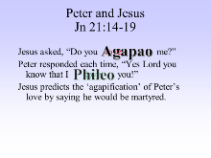
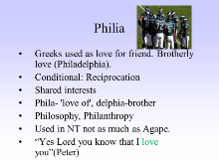
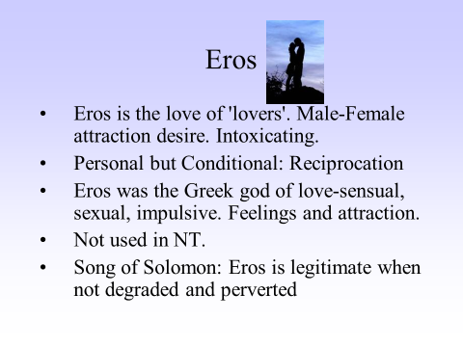 | Is it not true that, when we love and are loved, we experience in our life a glimpse of the divine? Every true lover talks about eternity: “I will love you  forever; it seems that we were intended to meet from forever.” The Spanish poet Bécquer wrote a romantic poem that expressed this connection  between love and the sacred: Today earth and heaven smile upon me;  Today the sun reaches the depth of my soul; Today I saw her . . . I saw  her and she looked at me . . . Today I believe in God!
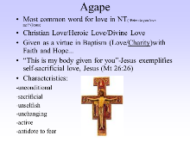 | ***Read CCC Sections  - Scripture never says God is justice or beauty or righteousness, though he is just and beautiful and righteous. But "God is love" (1 Jn 4:8).  - Love is God's essence, his whole being. Everything in him is love(Agape)  - The Paschal Mystery was God's great act of love.  - God is in a relationship of love (Holy Trinity)  - If God is not a Trinity, God is not love. For love requires three things:  - a lover, a beloved a relationship between them.  - If God were only one person, he could be a lover, but not love itself. The Father loves the Son and the Son loves the Father, and the Spirit is the love proceeding from both, from all eternity.  - Jn 3:16"For God so loved(Agape) the world that he gave his one and only Son...,  - "Greater love (Agape) has no man than this, that a man lay down his life for his friends.“ Jn 15:13  - A free and carefully chosen decision to offer love. (common priesthood of Baptism)  - “In agape you give yourself away, not just your time or work or possessions or even your body. You put yourself in your own hands and hand it over to another. And when you do this unthinkable thing, another unthinkable thing happens: you find yourself in losing yourself.” Peter Kreeft
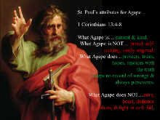 | We Receive His Love: He is so full, in fact, that it overflows, and He can't help but love us." C.S. Lewis, The Four Loves  Infusion-Theological Virtues : Faith, Hope and Love (Agape)  ‘Theo’-rooted in God and come to us as a gift from God.  Baptism-’In seed form’. Needing to be developed by cooperating with grace.  On one occasion Jesus was asked: "Master, which is the great commandment of the law?" (Matt. 22:36). He answered: " . . . Thou shalt love(Agape) the Lord thy God with all thy heart, and with all thy soul, and with all thy mind. This is the first and great commandment. And the second is like unto it, Thou shalt love(Agape) thy neighbour as thyself.”  - Summation of 10 commandments  - 1-3 Agape of God  - 4-10 Agape of Neighbor
Fiddler on the Roof
Do you love me?  (Golde)  Do I what?  (Tevye)  Do you love me?  (Golde)  Do I love you?  With our daughters getting married  And this trouble in the town  You're upset, you're worn out  Go inside, go lie down!  Maybe it's indigestion  (Tevye)  "Golde I'm asking you a question..."  Do you love me?  (Golde)  You're a fool  (Tevye)  "I know..."  But do you love me?  (Golde)  Do I love you?  For twenty-five years I've washed your clothes  Cooked your meals, cleaned your house  Given you children, milked the cow  After twenty-five years, why talk about love right now?  (Tevye)  Golde, The first time I met you  Was on our wedding day | I was scared  (Golde)  I was shy  (Tevye)  I was nervous  (Golde)  So was I  (Tevye)  But my father and my mother  Said we'd learn to love each other  And now I'm asking, Golde  Do you love me?  Golde)  I'm your wife  (Tevye)  "I know..."  But do you love me?  (Golde)  Do I love him?  For twenty-five years I've lived with him  Fought him, starved with him  Twenty-five years my bed is his  If that's not love, what is?  (Tevye)  Then you love me?  (Golde)  I suppose I do  (Tevye)  And I suppose I love you too  (Both)  It doesn't change a thing  But even so  After twenty-five years  It's nice to know

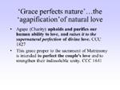
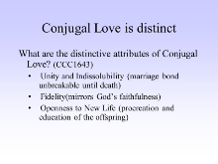
 | Read Sections of Handout, ‘Catechesis into the Fullness of Love’
 | Reformation
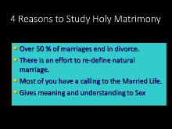
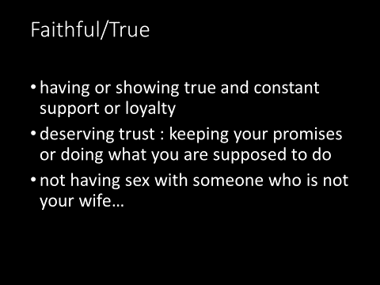
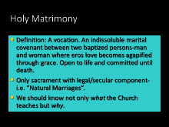
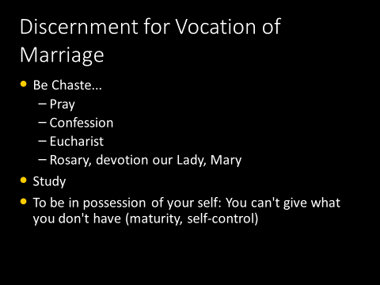
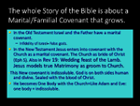 | The underlying theme throughout the Bible is God wants to “marry” us (Hos. 2:19). Indeed, God wanted to make his nuptial plan for us so obvious that he created our very bodies, male and female, to prepare us for this eternal, mystical marriage. Human marriage then is the sign and the sacrament, revealing the eternal reality of the union of Christ and his Church. Jesus spoke of this as well when he addressed the Sadducees saying, “For in the resurrection they neither marry nor are given in marriage, but are like angels in heaven” (Mt. 22:30). Jesus reaffirms that earthly marriage is not the ultimate end in itself, but a sign of the heavenly marriage to come. It is a harbinger of the final truth, when the earthly sign will at last give way to the heavenly reality. In the resurrection, the body will be raised eternal, incorruptible, spiritualized and divinized. Yet, as with any marriage proposal, mutual consent is necessary. We must give our “yes” through faith and the offering of ourselves.  Marriage was built upon this notion of a free, sincere gift of self to another. The gift of self in marriage is a sign and analogy of Christ’s total gift of himself for his Church. At the Last Supper, when Jesus institutes the Eucharist, he says, “This is my body which is given for you” (Lk. 22:19). Jesus offers himself bodily for us, his bride. His total self-offering of his body is consummated with his crucifixion on the cross. In the same way then, the Eucharist is a renewal of Christ’s spousal gift of his body. In the words of Jesus, “He who eats my flesh and drinks my blood abides in me, and I in him” (Jn. 6:56). This is our one flesh communion.
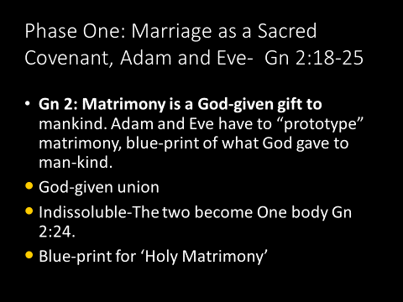
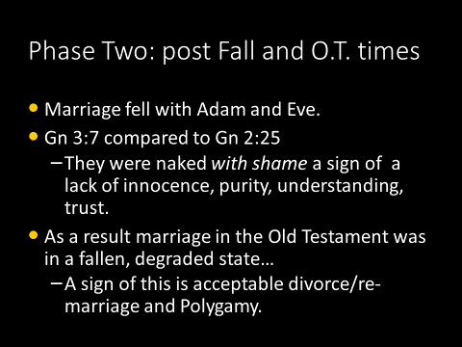
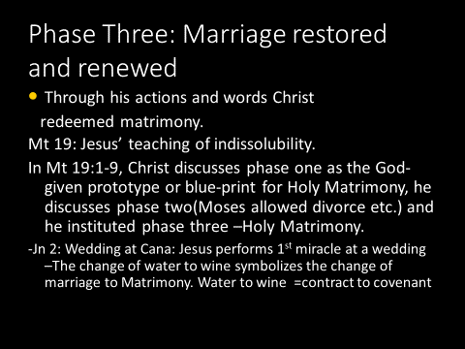
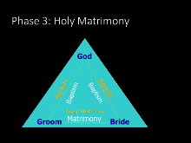
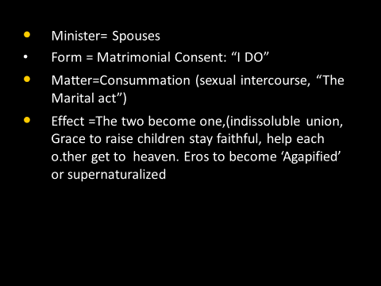
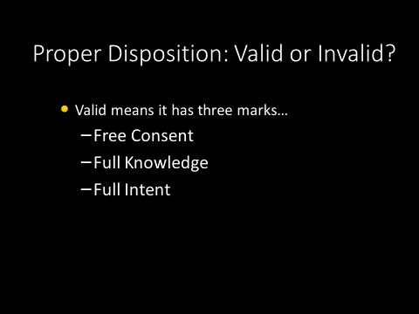
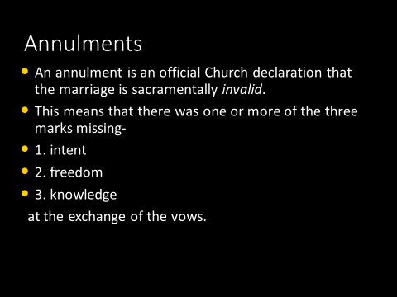
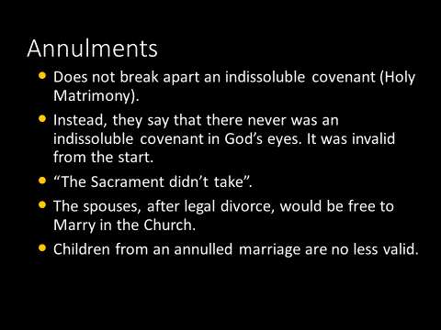
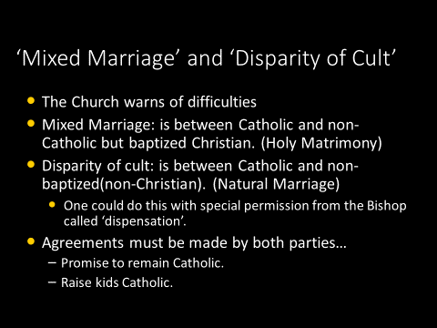
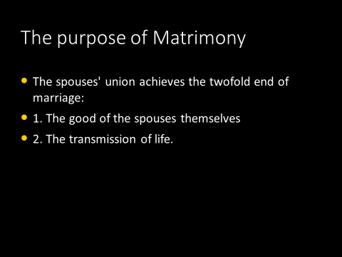
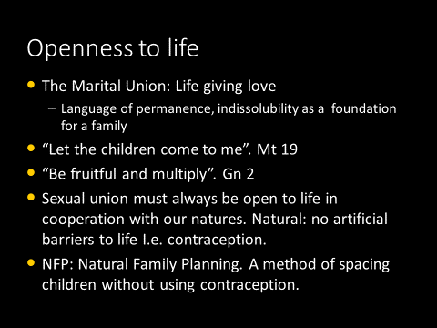 | All-Pro NFL quarterback Philip Rivers pointed out that self control “doesn’t end when you get married. Chastity is still part of your marriage.” He and his wife practice NFP, and he admitted that “it can be hard as ever sometimes. But it makes us stronger and love each other more. It allows you to love in many different ways. . . . That part of our relationship has strengthened us.”[6]  During the times of abstinence, the spouses learn to express love in nonsexual ways. As a result, the intimacy between them deepens. In the meantime their anticipation of the marital act will intensify its joy. Furthermore, even the act of abstaining from intercourse can be a loving gesture, since not having more children at that time may be best for the family.
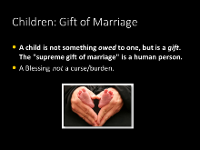 | Show JPII & Kids  CONTRASTED TO…  HBO’s host of “Real Time, Bill Maher, says that a new holiday should be in order for those who don’t want to have children.  During Friday night’s airing of the show, Maher — who has never married — lobbied for the new holiday, which he wants to name, “I Didn’t Reproduce Day.”  “I’m just saying, where’s the holiday for single people?” he asked. “We don’t have a day. Only happy hour.”  “We spent a lifetime being the cool aunts and uncles, but while we celebrate everybody else, nobody ever celebrates us, and they really should because you know what Mother Nature loves even more than electric cars? Condoms,” Maher quipped, but his “joke” didn’t stop there.  The liberal talk show host added, “There’s nothing literally that you can do that is better for the environment than to not produce another resource-sucking, waste-making human being, probably with a bad attitude.”  http://www.theblaze.com/news/2017/06/24/liberal-wants-holiday-for-those-who-dont-want-resource-sucking-waste-making-human-beings/
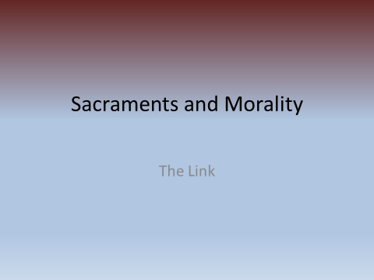
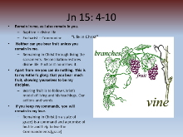 | Theosis Quote by CS Lewis…  “He came to this world and became a man in order to spread to other men the kind of life He has – by what I call ‘good infection.’ Every Christian is to become a little Christ. The whole purpose of becoming a Christian is simply nothing else”  “The command Be ye perfect is not idealistic gas. Nor is it a command to do the impossible. He is going to make us into creatures that can obey that command. He said (in the Bible) that we were ‘gods’ and He is going to make good His words. If we let Him – for we can prevent Him, if we choose – He will make the feeblest and filthiest of us into a god or goddess, dazzling, radiant, immortal creature, pulsating all through with such energy and joy and wisdom and love as we cannot now imagine, a bright stainless mirror which reflects back to God perfectly (though, of course, on a smaller scale) His own boundless power and delight and goodness. The process will be long and in parts very painful; but that is what we are in for. Nothing less. He meant what He said.”  St Catherine’s Vision of Baptized soul.
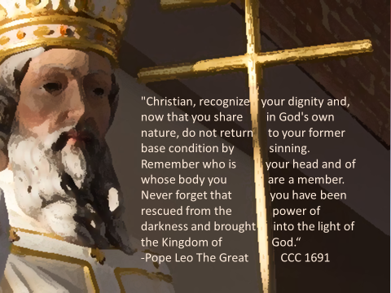 | 1692 The Symbol of the faith confesses the greatness of God's gifts to man in his work of creation, and even more in redemption and sanctification. What faith confesses, the sacraments communicate: by the sacraments of rebirth, Christians have become "children of God,"² "partakers of the divine nature."³ Coming to see in the faith their new dignity, Christians are called to lead henceforth a life "worthy of the gospel of Christ."⁴ They are made capable of doing so by the grace of Christ and the gifts of his Spirit, which they receive through the sacraments and through prayer.
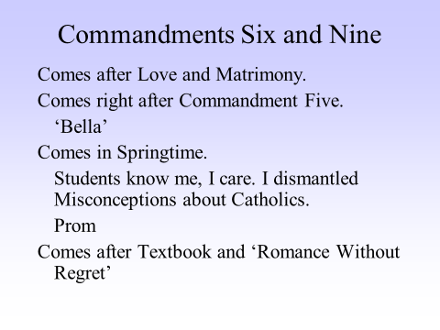
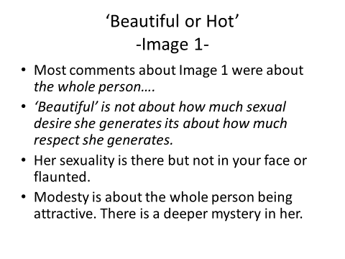
 | On the Sermon on the Mount, Christ again calls us back to the way it was in the beginning. Jesus says, “everyone who looks at a woman lustfully has already committed adultery with her in his heart” (Mt. 5:28). He challenges us to find a new, pure way of looking at each other, with custody of our eyes and a purity of heart, capable of seeing the person as the image of God. Jesus calls us to conversion, and a mastery of self. This is Jesus’ new ethos of the heart, in which our eros is infused with an agape love.
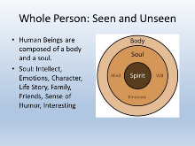
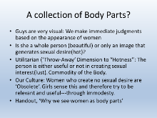
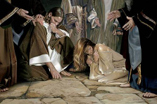
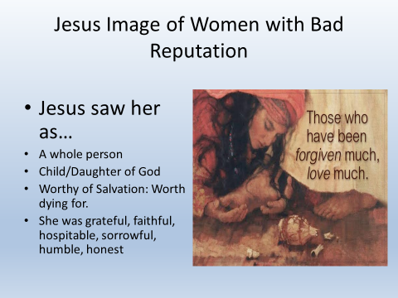
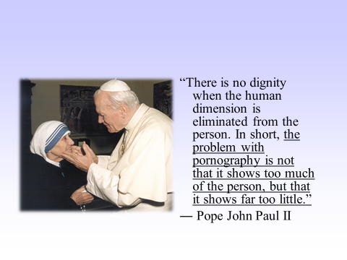
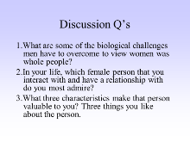
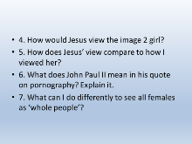 | Pope Francis Video Clip
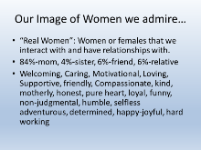
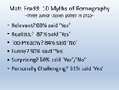
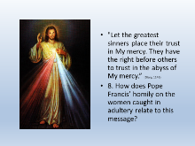
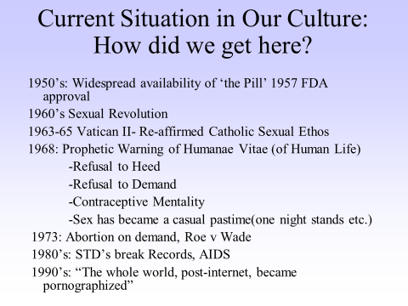
The staggering loss of sexual ethics over the last fifty years at least, as part of the Sexual Revolution, (and subsequent “culture of death”) shows the savage assault that has taken place on marriage, sexuality, procreation, and the family. We can readily see so many counterfeit signs that have gained widespread cultural acceptance, sadly even by many within the Church. As John Paul declared, “The ‘great mystery’ is threatened in us and all around us.” Not surprisingly, progressive sexual morality, especially the redefinition of both marriage and gender, is now the tip of the spear threatening religious freedom.

Bill 89
Parents who oppose or criticize the LGBT agenda will be considered potential “child abusers” and may have their children taken away by the state, according to the new bill. If the parents are ruled to be abusers by failing to wholeheartedly support their child’s gender choice, that child “can be removed from that environment and placed into protection where the abuse stops.” Bill 89, also known as “The Supporting Children, Youth and Families Act of 2017,” received Royal Assent and was passed in Ontario by a vote of 63 to 23.
Bill C-16 Authorities there now fine citizens up to $250,000 for the novel crime of “mis-gendering” — referring to people by any words other than their pronouns of choice (including newly constructed words such as zie/hir, ey/em/eir and co).
“They” is also a popular choice, transforming the plural into a new singular, with its advocates arguing (misleadingly, in my opinion) that such use reaches back several hundred years. I have been taken to task for my refusal to abide by the wishes of those demanding such changes to my speech. What are my reasons?

Hope -- Authentic ecumenism
As for our relations with other Christians: The disdain often shown toward religion today has the ironic effect of drawing many believing Christians together across lines that once divided them. I have more friends who are pastors, scholars and persons I deeply admire in other, non-Catholic Christian communities than I ever thought possible 45 years ago as a young priest. Denominational labels are often less important than whether a person really believes in Jesus Christ, the Word of God and the core of the Christian faith. Our differences are important. They can't be minimized. But the common faith we share in Jesus Christ is equally important.
Live as a committed Christian, and de facto you will begin to stand apart from others, and never more than in our radically secularist age. If you don't, you're doing it wrong. You will also, inevitably, gravitate towards your co-religionists. And not because of an exclusionary elitism, but for any number of perfectly healthy reasons: the need for communal worship, for mutually enriching friendships built upon shared convictions, to encourage one another in the arduous battle for holiness, to name a few. A solitary Christian is an impoverished Christian, and a vulnerable one.

The Christian faith is growing rapidly in much of the world. But we rarely hear about it because it doesn't fit the standard secular narrative. So we over-focus on our own problems. That's natural. But it's also dangerous, because when we lose a sense of the larger picture, we can lose confidence in our own beliefs. The reality is this: Even in countries like the United States and Australia, God is raising up plenty of strong young clergy, religious and laypeople, and movements and communities committed to renewal. They're the future. They need to be encouraged. That's where we need to focus. God will take care of the rest. There's no reason to be bitter or afraid.

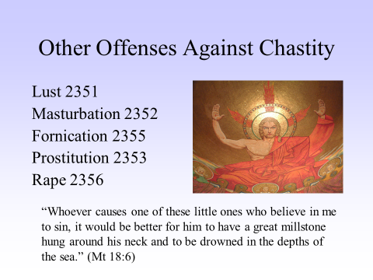 | CS Lewis on Masturbation:  CS Lewis on Masturbation “For me the real evil of masturbation would be that it takes an appetite which, in lawful use, leads the individual out of himself to complete (and correct) his own personality in that of another (and finally in children and even grandchildren) and turns it back; sends the man back into the prison of himself, there to keep a harem of imaginary brides.  "And this harem, once admitted, works against his ever getting out and really uniting with a real woman.  "For the harem is always accessible, always subservient, calls for no sacrifices or adjustments, and can be endowed with erotic and psychological attractions which no woman can rival.  "Among those shadowy brides he is always adored, always the perfect lover; no demand is made on his unselfishness, no mortification ever imposed on his vanity.  "In the end, they become merely the medium through which he increasingly adores himself. . . . After all, almost the main work of life is to come out of our selves, out of the little dark prison we are all born in. Masturbation is to be avoided as all things are to be avoided which retard this process. The danger is that of coming to love the prison.”  - Personal Letter From Lewis to Keith Masson (found in The Collected Letters of C.S. Lewis, Volume 3)
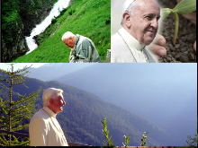
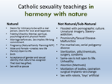
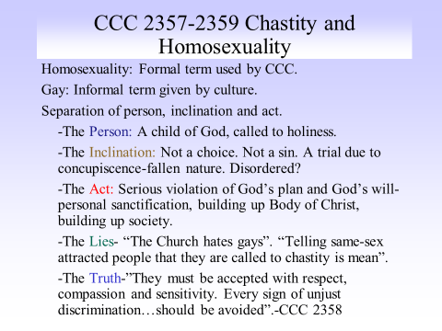 | Those who control the language of a debate largely control the outcome. Words shape thought. An expression like "marriage equality" is deeply misleading and arguably dishonest. But it's also very effective. It bypasses serious thought and goes straight to the emotions that surround the word "equality ." So it's vital for Catholics to know and understand what their faith teaches, to speak the truth, and to challenge the words of a public debate when they mask lies and ambiguities  The Church never demeans a person under the influence of homosexuality. That is, the Church is always able to see the goodness of “the person” even as this person may be caught up in homosexual thoughts, words, and actions. To the Church, this person is always other and more than the homosexuality. - Why Words Matter When It Comes to Homosexuality homosexualityhttp://www.crisismagazine.com/2015 JOHN COLLINS
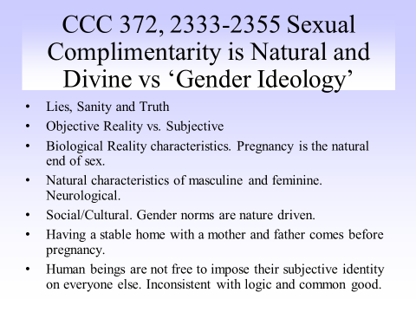 | God teaches us to love as God loves, through the complementary sexes, as imprinted upon our bodies. This reveals the spousal meaning of our very existence. Jesus himself reaffirms the truth of dual genders and their nuptial meaning. When the Pharisees question him about divorce, Jesus answers them, “Have you not read that he who made them from the beginning made them male and female, and said, ‘For this reason a man shall leave his father and mother and be joined to his wife, and the two shall become one flesh’? So they are no longer two but one flesh” (Mt. 19:4-6). The two become one in the primordial sacrament of marriage: It was the original sacrament, the prototype that foreshadowed the marriage union of Christ with the Church. St. Paul refers to this marriage of Christ with the Church as a “great mystery” (Eph. 5:32). Married couples are a sacramental sign of the divine bridegroom and his bride. In reference to the marriage of husband and wife, and Christ and the Church, John Paul states, “these two signs together, making of them the single sign, that is, a great sacrament.”  Gender Theory Pediatricians back Pope Francis on ‘gender theory’  - Thomas D. WilliamsAugust 9, 2016CRUX CONTRIBUTOR  “gender theory” generally refers to the idea that sexual orientation and identity are self-determined rather than given in nature, and it’s seen as a cornerstone of a secular Western vision.  Pope Francis: “A great enemy of marriage today is the theory of gender,” Francis told a group of religious men and women and pastoral agents in Georgia. “Today, there is a global war trying to destroy marriage… they don’t destroy it with weapons, but with ideas. It’s certain ideological ways of thinking that are destroying it…we have to defend ourselves from ideological colonization,” he said.  “Today, schools are teaching children-children!-that everyone can choose their own sex. And why is this being taught? Because their textbooks are chosen by the people and institutions that give money. This is ideological colonization, promoted by very influential nations. This is terrible,” the pope said.  Typical Response: Hurtful (‘Hateful’ if it wasn’t the Pope), Ignorant…  Sarah McBride, a transgender woman and National Press Secretary of the pro-LGBT Human Rights Campaign, said that Francis’s words were “not only hurtful, and frankly harmful, but really demonstrating a misunderstanding of what it means to be transgender.”  According to the most recent studies, the pope’s views are not only theologically orthodox, but scientifically sound. Title: Transsexuality Among Twins: Identity Concordance, Transition, Rearing, and Orientation. Author: Milton Diamond Ph.D. Published in: International Journal of Transgenderism, 14:1, May 2013, pp 24-38, found that only 20 percent of identical twins both identified as transgender, despite their identical DNA. Since identical twins contain 100 percent of the same DNA from conception, and develop in exactly the same prenatal environment, if gender identity were innate, the concordance rates would be close to 100 percent-rather than 20 percent.  According to the ACP report, twin studies alone disprove the theory of an “innate gender identity” arising from prenatally “feminized” or “masculinized” brains trapped in the wrong body. This theory is rather “an ideological belief that has no basis in rigorous science,” the doctors assert.
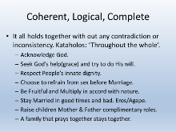
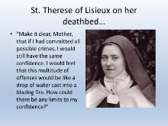
Student Example PPT | Handout Porn Assignment rubric
Resources | Handout, web links etc.

